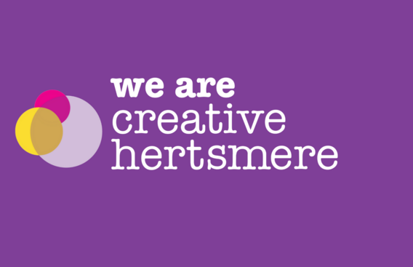
Hertsmere Arts and Culture Newsletter
Welcome
Welcome to the monthly ‘We Are Creative Hertsmere’ newsletter, produced by Hannah, Hertsmere’s Creative Strategy Support Officer.
This time, you will find highlights from recent events and a sneak peek at what’s on the horizon in the creative sector. We will now also include the date of the next Culture Connect meeting, so if you would like to meet your fellow creatives in person, now is your chance.
If you have any events or stories you’d like us to feature, please don’t hesitate to get in touch.

Join our creative community networking group
Do you work in the voluntary and community sector? Does your group focus on creative pursuits? Are you a freelancer working with charities? If so, you're welcome to attend our bi-monthly community networking group.
What to expect:
- A space for creatives to gather, engage in discussion, and make connections
- Opportunities to meet individuals who share your interests
- Guest speakers and information-sharing sessions to help you develop your skills and resilience.
Next Meeting:
Date: Tuesday 3 November 2026
If you’re interested, please email Hannah Oliver

August/September highlights
Heritage Open Days at Bushey Rose Garden
In September, Hertsmere residents had the rare experience of a guided tour of Bushey Rose Garden, learning about the marvels of heritage gardening, Bushey’s walled garden, and its extensive art history.
Bushey Rose Garden plays an important role in the Bushey community due to its former use as an art school. The design of the garden is the result of a collaboration between artist Sir Hubert von Herkomer and landscape architect Thomas Mawson. You can see more than 40 different varieties of roses and over 4000 different plants.
This event was held as a part of the Heritage Open Days Festival 2026. A big thank you to Councillor Oakley, Officers from HBC, the Friends of the Rose Garden, and our volunteer guides who made the event such a success.

Aldenham Art Festival
Last month, Aldenham Art Festival returned for its eighth time. The festival was once again a success, providing a great experience for visitors and artists alike. This year they had 86 artists in total showcasing their work, and the church was filled to the brim with pieces of art decorating the walls and pews. A warm and welcoming, family-friendly festival is a great edition to Aldenham’s cultural landscape.
If you would like to take part in next year's festival, visit the Aldenham Festival website.

From the community
Birthday Celebrations: How Bushey Library began
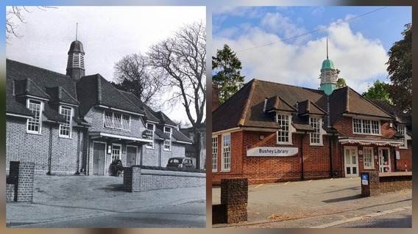
As part of Hertfordshire Libraries’ Centenary Year, the Bushey Library team has been celebrating its proud history as the first new library built by the countywide service. It officially opened on 30 September 1936.
At the start of the 1930s, it was decided that the people of Bushey should have a library. Rather than simply talking about it, a group of determined local women decided to make it happen.
In 1930, Ione Hearle started the library with nothing more than a few books in an oak chest in the hall of her home. On the very first day, books were issued to five young girls. The idea proved so popular that the ‘library’ soon outgrew its original home. Mr and Mrs Ellinger of Hartsbourne Grange generously offered the use of their garden studio, and within a few years the library had grown to an impressive 500 members.
In 1935, the organisers approached Hertfordshire County Council to secure a permanent library for Bushey as part of the newly established county-wide library service, now known as Hertfordshire Libraries. Bushey Library became the first purpose-built library in the new service.
The land on which the library stands today was gifted by a Mrs H M Nimmo of Sparrows Herne Hall. Construction cost £3,000, which would be equivalent to around £275,000 today. It proved to be money well spent. Now, 90 years later, Bushey Library is still serving the community from the same building, a lasting testament to the vision, determination, and community spirit of those remarkable local women who made it all possible.
For information on the birthday celebrations or other activities follow Bushey Library on Facebook @BusheyLibrary or have visit : www.hertfordshire.gov.uk/libraries
Hertsmere Year of Culture 2027
Grants🎁
Community organisations and voluntary groups across Hertsmere are being encouraged to apply for grants of up to £500 to help deliver local events and activities during Hertsmere’s Year of Culture 2027.
The funding will support projects, events and activities that celebrate creativity, bring people together and reflect the borough’s diverse cultural life throughout 2027.
Grants can be used as a one-off contribution towards revenue or capital costs, including equipment, specific projects, individual events or a programme of activities linked to the Year of Culture.
Councillor Chris Myers, Portfolio Holder for Street Scene, Parks, Leisure and Culture at Hertsmere Borough Council said:
“Hertsmere’s Year of Culture 2027 will be a chance to showcase the creativity, talent and community spirit that make the borough such a vibrant place. These grants will help local groups bring forward ideas that celebrate culture in all its forms and encourage residents to get involved throughout the year.”
There will be four funding rounds, with each round linked to three themed months during 2027.
Round 1: January (Books and Reading), February (Charity and Gratitude) and March (Dance)
Eligible groups are encouraged to prepare their applications ahead of the first deadline. Further details on eligibility and the application process will be available through the webpage Year of Culture Grants - Hertsmere Borough Council
Opening Showcase🎉
We’re delighted to invite you to be part of the Hertsmere Year of Culture 2027 Opening Showcase at Allum Hall on Sunday 10 January, from 1–4pm.
The event will officially launch a fantastic year-long celebration of creativity, culture, heritage and community across Hertsmere, bringing together local organisations, artists, community groups and residents.
Get involved:
- We are looking for local performers to deliver a 20-minute performance that celebrates the brilliant creativity and talent within our borough.
- We are looking for local organisations to have a stall at the event. Use this opportunity to raise awareness of your organisation and showcase your work, projects and activities
If you are interested, please get in touch and we can provide further details about the event and performance arrangements. Please email Hannah Oliver
Museum Corner
Bushey Museum and Art Gallery
"St Hilda's School: A Hundred Year History" Exhibition
New to the Jubilee Room this month is a wonderful mixed media exhibition on local school St Hilda's. This all-girls primary school was a constant presence on London Road for over a hundred years before closing last year.
The exhibition will show some of the photographs and items of interest exploring the origins of the house, the life of the school and its founder, Miss Violet Curry, who shaped the school from the beginning. The exhibition reflects her love of nature and the importance she gave to lessons outside the classroom, which continued at St Hilda's until the school closed. These include the display of her extraordinary personal journals which are beautifully illustrated with watercolour pictures of the natural world. This is an opportunity to see how the school began and evolved over time.
Open Thursday to Sunday, 11am to 4pm.
To find out more, visit: Bushey Museum in Hertfordshire. Local history and Herkomer's Art School.

Elstree and Borehamwood Museum
"Going Down the Village" Reminiscence Meetings @ 96 Shenley Road
Take a trip down memory lane by 'going down the village' with a free monthly reminiscence group for the over 60s at Elstree and Borehamwood Museum.
The next meeting will be on Tuesday 13 October, at 10.30am.
Current exhibition: A fantastic new exhibition opened in June that showcases props and costumes associated with Elstree Studios over its 100-year run.
The museum is open Tuesday to Thursday between midday and 6pm, and Saturday from 10am to 3pm.
To find out more, visit: Elstree & Borehamwood Museum

Potters Bar Museum
"The Railway comes to Potters Bar" Exhibition is closing at the end of October.
If you would like to see this great exhibition on 175 years of railway history in the Potters Bar and South Mimms area, you have only a few weeks left!
Next History Talk: Hertfordshire and the Slave Trade
A speaker from the Hertfordshire Archives and Libraries Service will be at the URC Church, Darkes Lane (EN6 1BZ) on Monday 19 October 2026. The talk will start promptly at 8pm. Free parking and refreshments available.
Admission £1 members, £2 non-members
Open Tuesday and Wednesday 2:30pm to 4:30pm and Saturday 11am to 1pm.
To find out more, visit: Potters Bar Museum & Potters Bar and District Historical Society

Radlett and District Museum
NEW DISPLAY: Playing for Radlett
Sports has long been woven into Radlett life. It has brought people together across generations.
Playing for Radlett explores seven sports: cricket, rugby, tennis, squash, golf, football and bowls. This informative and engaging display tells the stories of the history, events, people and places that enabled Radlett's sporting life to flourish, and invites visitors to share their own memories of Playing for Radlett.
Dates for your Diary
Monthly free Children's colouring sessions - first Saturday in the month 10am-12pm. See website for details.
OPPORTUNITY: Radlett Museum is looking to appoint a new Secretary to the Trustee Board, following the planned retirement of the incumbent in December 2026. Please get in touch if you or someone in your network might be interested in this opportunity.
Open Wednesday and Saturday between 10am and midday.
To find out more, visit:https://www.radlettmuseum.co.uk/

Upcoming Events
Looking for more upcoming local events? Check out Borehamwood Radio's Local Events Calendar here: Local Events | Boreham Wood Radio

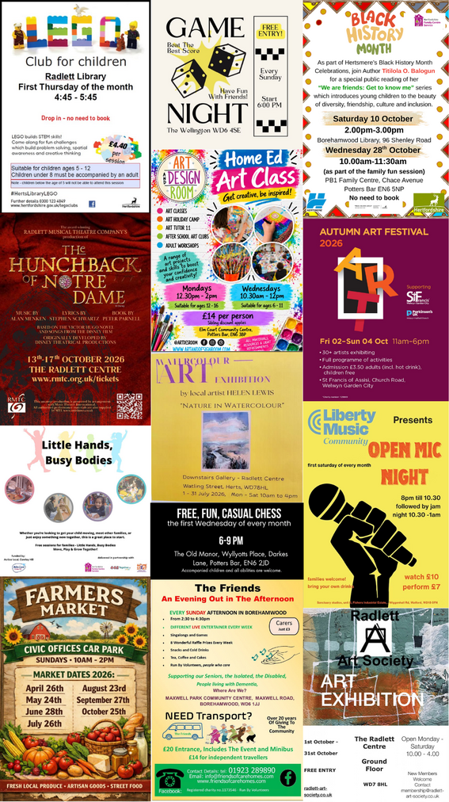

It’s a win-win situation when you play Hertsmere Community Lottery!
Support local good causes and be in with a chance to win great prizes by joining the Hertsmere Community Lottery for just £1 a week. As well as weekly cash prizes of up to £25,000, tickets for the Saturday 31 October draw also enter you into a special Super Draw to win a brand new iPhone 18 Pro Max! Whether you play weekly or just for the Super Draw, it’s a simple, fun way to give back, with thousands already raised for local charities—making it a true win-win.

