
Potters Bar Community Connections
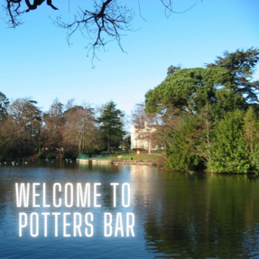 |  | Keeping Potters Bar connected  Welcome to the latest edition of the Potters Bar Community Connections newsletter, in which you can find information about news and events in the local community.

Dementia Support Event
Our free community dementia support event will take place on Wednesday 18 November from 12pm-2pm at Bushey Rangers FC Clubhouse, Moatfield Road, Bournehall Lane, Bushey, WD23 3JU. The venue has free parking on site.
The drop-in event will include talks, information stalls, conversations about dementia and memory concerns and free tea and coffee. Everyone is welcome, and no booking is required.
For more information, call 020 8207 2277 or email community.services@hertsmere.gov.uk
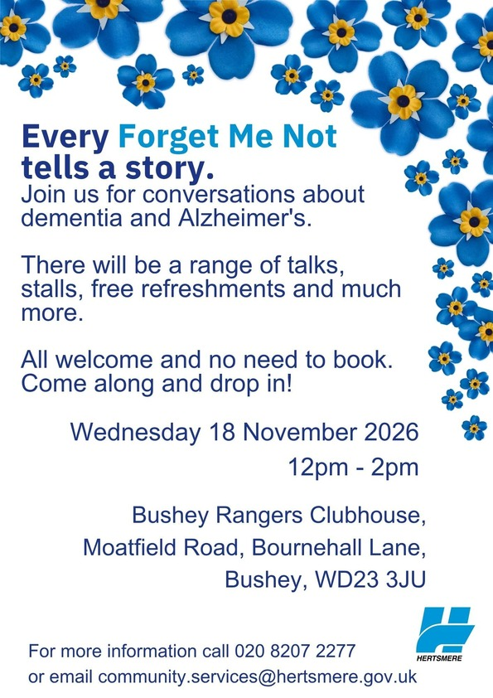

SightLife Potters Bar
Looking to connect with others who are visually impaired in Hertfordshire? SightLife have just started a new group in Potters Bar! SightLife is a friendly monthly support group where you can enjoy a warm drink, cake, conversation, and the chance to make new friends in a welcoming environment.
The group run on the first Thursday of each month from 11am-1pm at the Wyllyotts Theatre Café, Potters Bar, EN6 2HZ.
For more information please email Office@hertsvisionloss.org.uk or call 01707 324680.
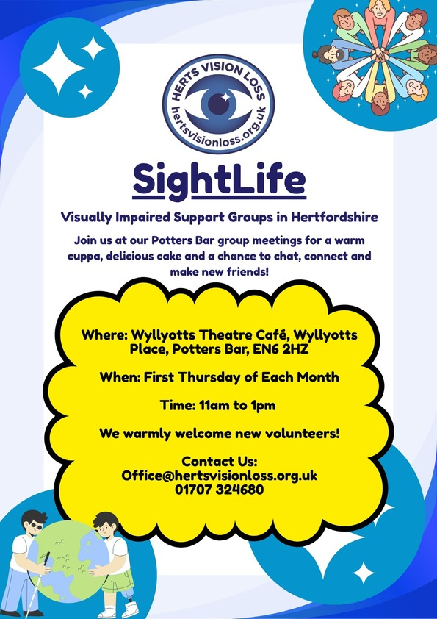
Hertsmere Mencap Charity Padel Tournament
Join Hertsmere Mencap for their Charity Padel Tournament for a fun day of sport and fundraising. Held at Paddlestars, Tabard Rugby Football Club, Radlett WD7 7JN, the event will raise vital funds for Hertsmere Mencap, supporting local people with learning disabilities and their families.
Whether you're a seasoned player or new to padel, it's a great opportunity to get involved, enjoy some friendly competition and support an important local charity. Sign up today and help make a difference in our community. for more information please contact padel@hertsmeremencap.org.uk.
Register your team here: Hertsmere Mencap Charity Padel Tournament



MPAA Open Days
Thinking about a career in performing arts? MPAA in Bushey is hosting a series of open days for prospective students and their families. Visitors can tour the academy, watch singing, acting and dance classes in action, meet current students and faculty, and learn more about the BA (Hons) Musical Theatre Performance degree which is validated by the University of West London.
The Open Days may also include a practical dance class, giving aspiring performers the chance to experience MPAA's industry-led training first-hand. It's a great opportunity to explore the facilities, ask questions and discover whether professional musical theatre training is the right next step.
Find out more about MPAA and register for an open day here: Musical Theatre Open Days in Bushey | MPAA
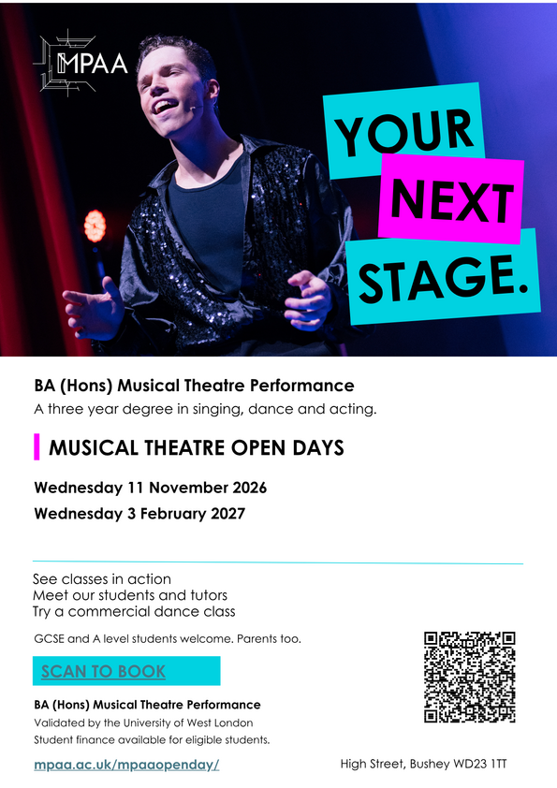

Christmas at Blenheim Palace Trip
Christmas Day Trip organised by Active Generation. The ticket includes coach travel and entry to the Christmas Light Trail. This Christmas step into the sparkle on the world-class Illuminated Trail at Blenheim Palace and stock-up on inspired presents in the Christmas Market. With new surprises around every corner, this spectacular trail boasting more than a million lights, has everything you need for an unforgettable adventure immersed in seasonal song. A wonderful experience that includes a glimpse of Father Christmas himself!
This trip is due to take place on Thursday 10 December 2026 and costs £55 per person for travel and ticket. There are 2 pick up locations, The Venue Leisure Centre and Furzefield Leisure Centre. If you are interested please visit Blenheim Palace Christmas Trip | Wyllyotts Theatre to book your place!

Shrimad Rajchandra Mission Dharampur (SRMD) Meditation Retreat
Take some time out to relax, recharge and reconnect at the Find Your Calm Half-Day Meditation Retreat on Sunday 1 November, 7am-1pm at the SRMD London Spiritual Centre in Bushey. This welcoming retreat will explore the what, why and how of meditation through guided sessions designed to help participants find inner stillness, clarity and balance. The £20 ticket includes breakfast, making it the perfect opportunity to invest in your wellbeing and start the month feeling refreshed and centred. Register online to secure your place.
Located at the SRMD London Spiritual Centre, Bushey, WD23 3AD, you can book online here: Meditation Retreat

CPR Awareness Training
New CPR Awareness sessions are now available to book! Don't miss out on the opportunity to learn vital life-saving skills with the help of Potters Bar Lifesaving Club. Book your space on one of our upcoming sessions by calling 0208 207 2277 or emailing community.services@hertsmere.gov.uk
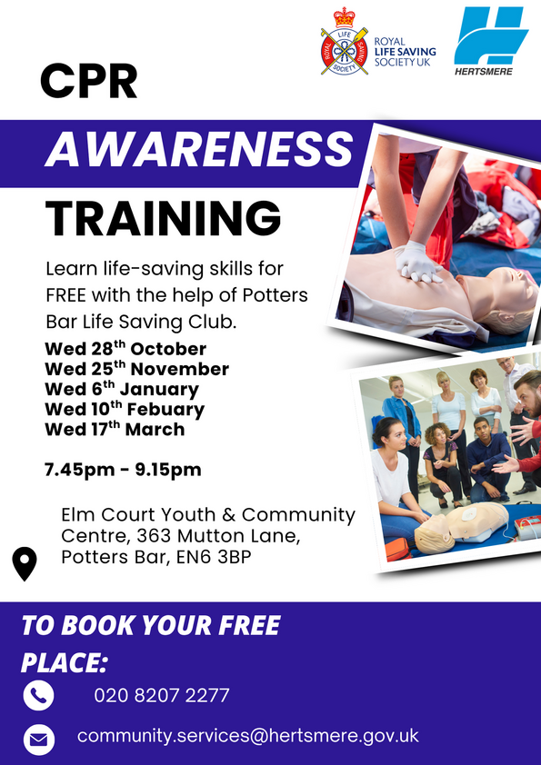
Free Job Fair and CV Workshop
Looking for a new job or want to improve your employability skills? Join the Job Fair & CV Writing Workshop for an afternoon of career support, networking and opportunities. Attendees can receive professional CV advice, meet employers from a range of sectors, learn about current vacancies, and access guidance from local support organisations.
Held at Tova Catering & Events in Borehamwood, the event offers a friendly and supportive environment to build confidence, develop job-search skills and take the next step towards employment. Complimentary refreshments will also be available.
For more information and to book your place visit Job Fair & CV Writing Workshop or contact the Jobs Plus team on 07484 482 742 or by email jobsplus@clarionhg.com

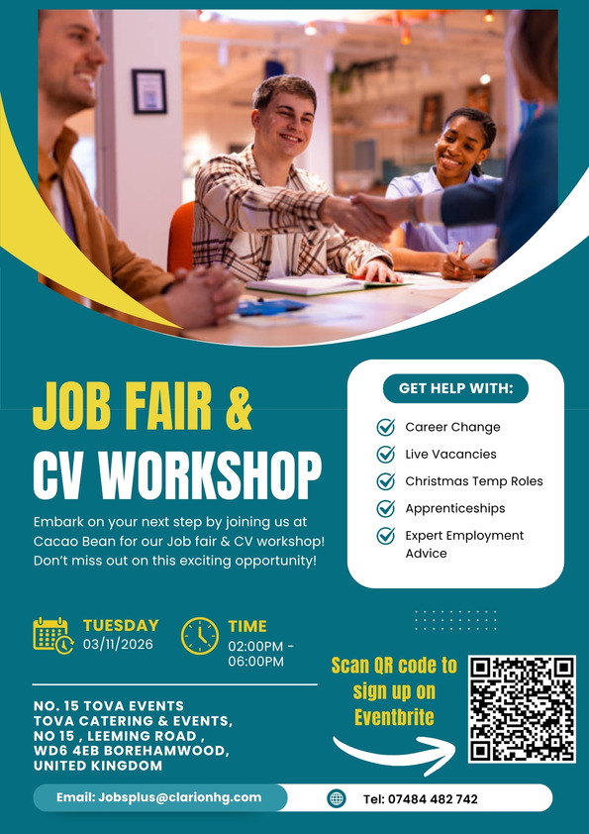

Hertsmere Community Lottery
It’s A Win-Win Situation When You Play Hertsmere Community Lottery!
Support local good causes and be in with a chance to win great prizes by joining the Hertsmere Community Lottery for just £1 a week. As well as weekly cash prizes of up to £25,000, tickets for the Saturday 28 November draw which go LIVE on Monday 2 November, also enter you into a special Super Draw to win a PS5 Pro Bundle or you can opt for £1000 in cash! You can choose which cause your ticket supports, with more of your money going directly to your chosen organisation than most major lotteries, and excellent odds of winning at 50:1. Whether you play weekly or just for the Super Draw, it’s a simple, fun way to give back, with thousands already raised for local charities—making it a true win-win. Play Here - Hertsmere Community Lottery

Hertsmere Community Lottery is now on Facebook and Instagram! You can stay up to date with all things lottery by following them here: HertsmereLotto Facebook, Hertsmere Lotto Instagram
If you would like to sign your organisation up to the Hertsmere Community Lottery please visit Good Cause's Signup

Potters Bar Community Spaces
Meet like-minded people, enjoy hot drinks, food, games, walks or just a chat at one of the many community spaces across Potters Bar and South Mimms. Most groups offer a warm space, beverage and snack or meal for free, or for a small donation. No need to book - just pop along to one of the groups and you'll be met with open arms.

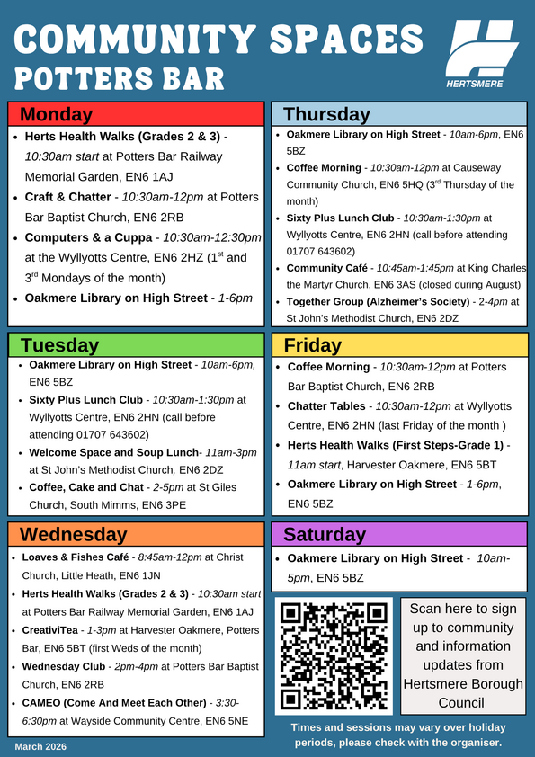
For more community spaces across the borough, please visit Hertsmere Community Spaces
If you're interested in the Herts Health Walks, please visit Hertfordshire Health Walks | Hertfordshire County Council for further information on the different grades and how to register for walks - please arrive at least 10 minutes before the start time of each walk.
We Move, She Moves sessions in Potters Bar
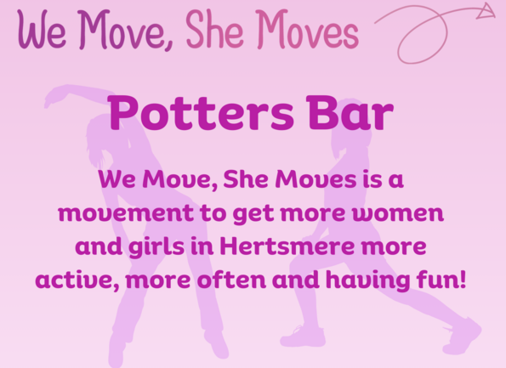
We Move, She Moves is a great way to get active and have fun! Take a look at the weekly sessions near you.
Activity | Date & Time | Location | Price
Tai Chi | Mondays 2-3pm | Wyllyotts Theatre | £5 (women only)
Active Trampolining | Mondays 8-9pm | Furzefield Leisure Centre | £3 (all genders 18+)
Yoga | Tuesdays 6-7pm | Oakmere Primary School | £5 (women only)
Pilates | Tuesdays 6:30-7:30pm | Wyllyotts Theatre | £5 (women only)
Please visit our website for our weekly timetable and Facebook page @WeMoveSheMoves for other session updates to find out what's on near you and how to book. For more information, email community.services@hertsmere.gov.uk or call 020 8207 7801.
Healthy Hub Hertsmere
Our Healthy Hubs provide FREE lifestyle support for individuals and their families covering mental health, physical activity, weight management, smoking cessation, health MOTs and nutritional advice, and sexual health testing kits.
Contact Lee or Nicola to make a face-to-face appointment or phone:
Lee Bruce: Lee.Bruce@inspireall.com or 07741 248852
Nicola O'Neill: healthyhub@communities1st.org.uk or 01727 649931
Find out more at the Healthy Hub website.
Alternatively, visit our Healthy Hub Self Service page, where you can access all of the services you need online. If you would like to access free health advice, fill out the enquiry form and we'll get back to you.
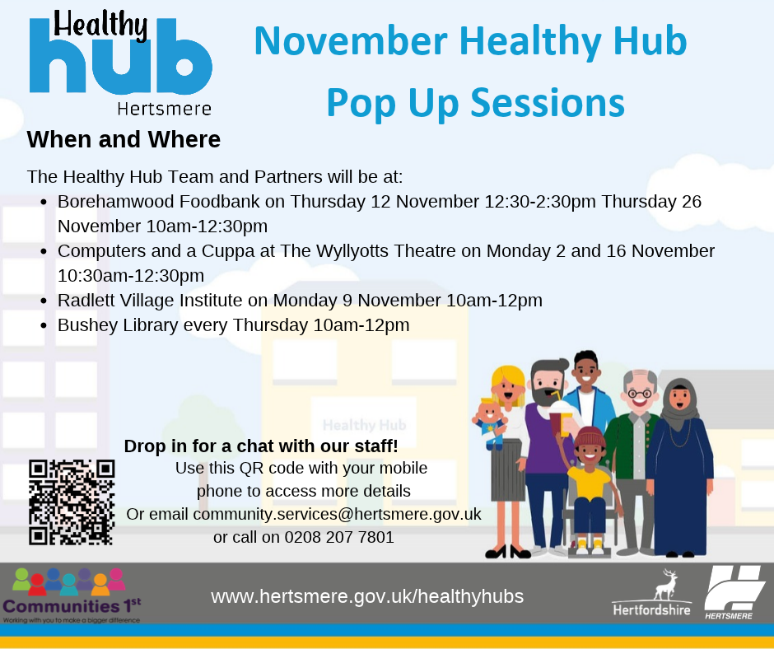
For further details on how to keep healthy in Hertsmere and to use our new interactive map, please use this link Health in Hertsmere.
You can also visit the Potters Bar Healthy Hub every Friday between 9.30am and 4.30pm at Wyllyotts Theatre. Services include exercise on referral, weight-loss advice, health MOTs, nutritional advice, public health services, fitness classes, mental health outreach, community support service and group activities.
Online and phone-ins also available. Call 07741 248852 or email Lee Bruce.

Worrying about Money - Find out what's available to you. Find all Financial Support - Hertsmere Borough Council.
Cost of Living Toolkit - If you need help or advice about the support you could receive with the cost of living, please visit Help to manage the cost of living | Hertfordshire County Council
Food Aid Providers - Use the Hertfordshire directory to find food support near you: Hertfordshire Directory - Food Support.
Pension Credit Support - If you're over State Pension age, you may be able to claim Pension Credit to top up your income. To find out if you are eligible for Pension Credit, contact Age UK Hertfordshire on 0300 345 3446 or email info@ageukherts.org.uk.
Mental Health Support - Advice and support for your happiness, wellbeing and mental health.
See what other services are available to you by visiting Cost of Living or calling 0300 123 4044.
www.hertsmere.gov.uk
customer.services@hertsmere.gov.uk
020 8207 2277
Civic Offices, Elstree Way, Borehamwood, WD6 1WA

