
Potters Bar Community Connections
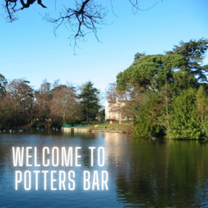 |  | Keeping Potters Bar connected  Welcome to the latest edition of the Potters Bar Community Connections newsletter, in which you can find information about news and events in the local community.

Quit smoking this October with Stoptober
Stoptober starts this October! Did you know if you make it to 28 days smoke free you are 5 times more likely to quit for good? - You don't need to do it alone - there are plenty of ways to get support this October to start your stop smoking journey.
- Get your free Personal Quit Plan here: Free Personal Quit Plan - NHS
- Register for one-to-one support here: Register for stop smoking support
- Sign up to a FREE Allen Carr's Easyway seminar: Allen Carr's Easyway seminar
- Download the free Smoke Free app for instant and convenient support: Smoke Free App
- Register for Swap to Stop, a service that provides you with a free vape starter kit to help you find the right aalternative to smoking: Swap to Stop
Or you can visit one of our Healthy Hubs today and our friendly team can help you start your journey: Find your local Healthy Hub
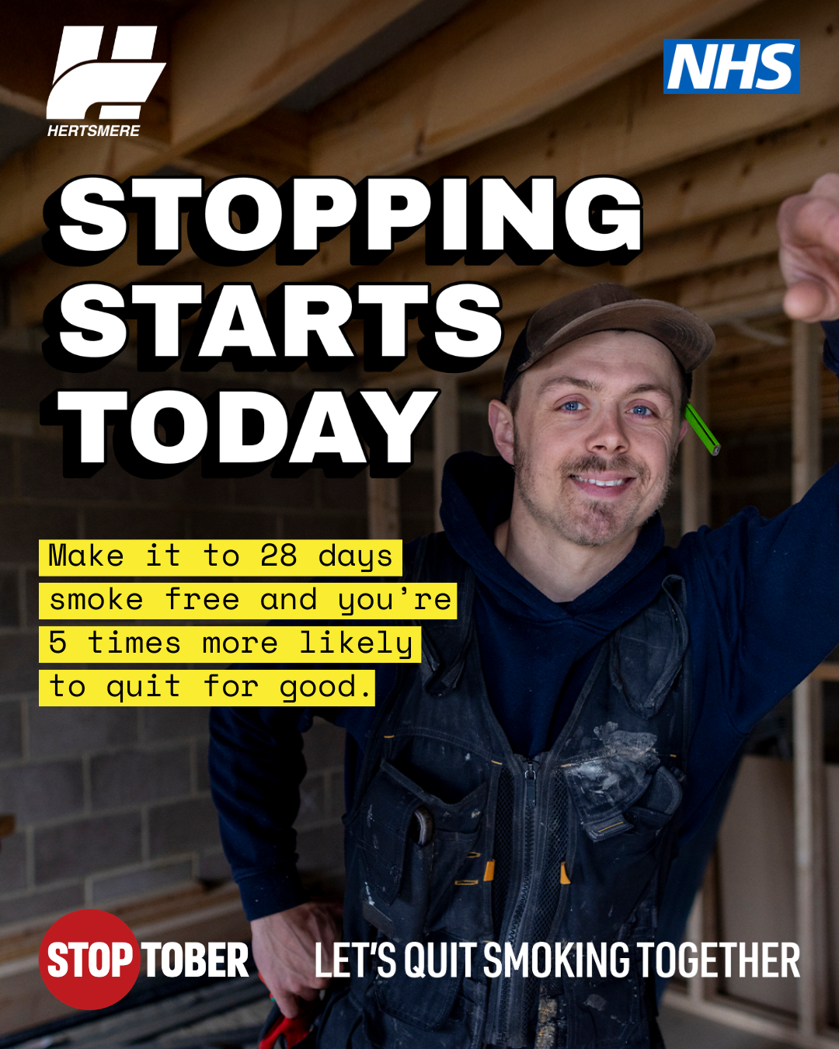

Black History Month


Carers in Herts support hub
Are you a carer in Hertfordshire? If so, there are local monthy supoprt hubs that take place each month at King Charles the Martyr Church, Potters Bar, EN6 3AS. The group organises regular speakers and activities aligned to group need as well as online groups available to attend too!
To book onto a session please visit Check out our latest events - Carers In Herts, call 01992 586 969 or email contact@carersinherts.org.uk
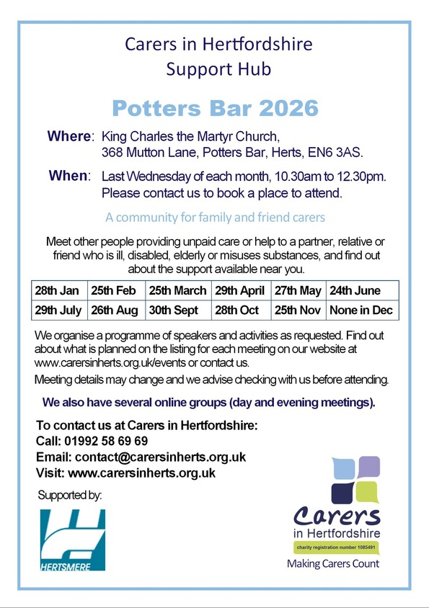

CPR Awareness Training
New CPR Awareness sessions are now available to book! Don't miss out on the opportunity to learn vital life-saving skills with the help of Potters Bar Lifesaving Club. Book your space on one of our upcoming sessions by calling 0208 207 2277 or emailing community.services@hertsmere.gov.uk
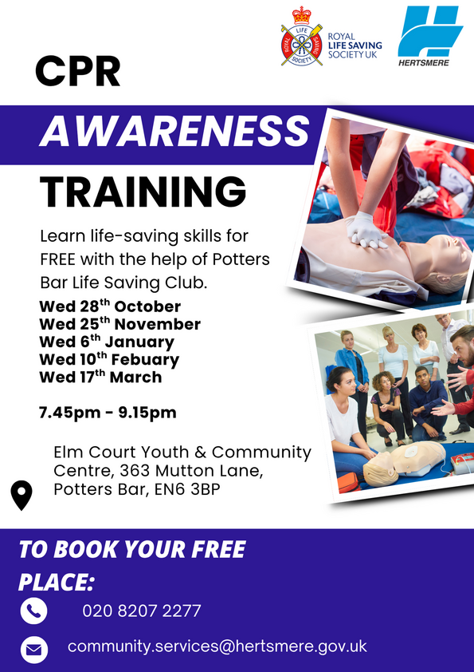

The Hall of Fame at Potters Bar Museum
Following the end of the current Railway exhibition, The Potters Bar Hall of Fame will open this October at the museum. The exhibition celebrates the remarkable people who have called Potters Bar home, from the 17th century to the present day. Visitors will discover stories of politicians, actors, scientists, writers, adventurers, sports personalities, inventors and military figures, alongside artefacts connected to their lives.
A special accompanying display will showcase rare postal history and philately, including the world-famous 1840 Penny Black stamp and a fascinating collection of early stamps from Europe, Latin America, Africa and Asia.
One featured resident is Commander Charles Lightoller (1874-1952), second officer of the RMS Titanic. Later a resident of Potters Bar, Lightoller was renowned for his service during both World Wars and for commanding his own yacht, The Sundowner, during the Dunkirk evacuation in 1940.
Potters Bar museum, located on the first floor of the Wyllyotts Theatre,is open Tuesdays and Thursdays from 2:30-4:30pm and Saturdays from 11am-1pm.

Shrimad Rajchandra Mission Dharampur (SRMD) YOGA
Looking to improve your wellbeing? SRMD Yoga offers a range of yoga classes, mindfulness sessions, meditation sessions including sound bath and sound healing classes designed to support your physical, mental and emotional health. All sessions are beginner friendly and are designed with your wellbeing in mind. Located at the SRMD London Spiritual Centre, Bushey, WD23 3AD, you can find out what sessions are available to you here: Upcoming Events | SRMD Yoga

Your Voice Matters focus group
Hertfordshire Mental Health, Learning Disability and Neighbourhood Health Partnership are inviting adult Black men who live, work, or have a connection to Hertfordshire, to take part in a discussion about mental health services.
Participants are being asked to share their views on:
- Why Black men may or may not use mental health support services
- What helps people feel comfortable seeking help
- How mental health services and information could become more relevant, accessible, and trusted
- Ways local services can improve communication and engagement with Black men in Hertfordshire.
Taking part involves joining a relaxed group conversation, sharing only what you feel comfortable discussing, and helping local services learn and improve. No previous experience of using mental health services is required, and a range of perspectives is welcomed.
The focus group takes place on 7 October 2026, from 6-8pm, at the South Hill Centre, Hemel Hempstead. Food will be provided and participants will receive compensation for their involvement.
To get involved please contact angela.hughes39@nhs.net
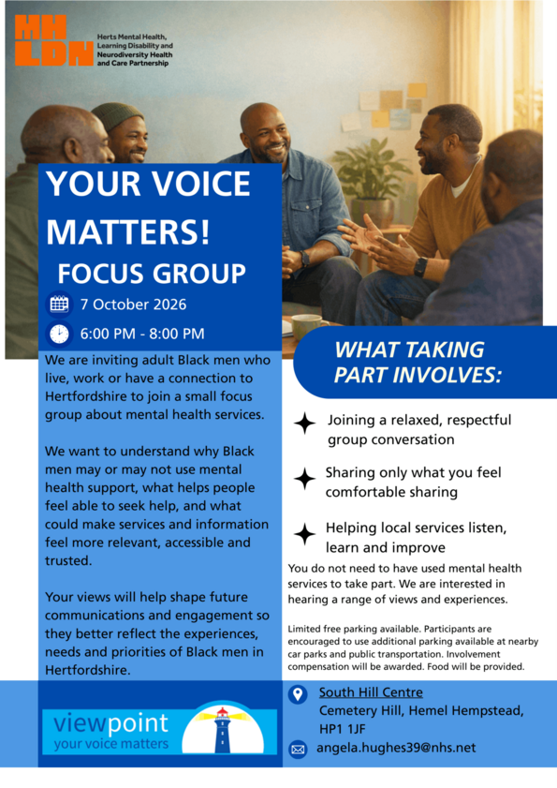

Hertsmere Community Lottery
It’s A Win-Win Situation When You Play Hertsmere Community Lottery!
Support local good causes and be in with a chance to win great prizes by joining the Hertsmere Community Lottery for just £1 a week. As well as weekly cash prizes of up to £25,000, tickets for the Saturday 31 October draw also enter you into a special Super Draw to win a brand new iPhone 18 Pro Max! You can choose which cause your ticket supports, with more of your money going directly to your chosen organisation than most major lotteries, and excellent odds of winning at 50:1. Whether you play weekly or just for the Super Draw, it’s a simple, fun way to give back, with thousands already raised for local charities—making it a true win-win.
Play Here - Hertsmere Community Lottery

Potters Bar Community Spaces
Meet like-minded people, enjoy hot drinks, food, games, walks or just a chat at one of the many community spaces across Potters Bar and South Mimms. Most groups offer a warm space, beverage and snack or meal for free, or for a small donation. No need to book - just pop along to one of the groups and you'll be met with open arms.
For more community spaces across the borough, please visit Hertsmere Community Spaces
If you're interested in the Herts Health Walks, please visit Hertfordshire Health Walks | Hertfordshire County Council for further information on the different grades and how to register for walks - please arrive at least 10 minutes before the start time of each walk.

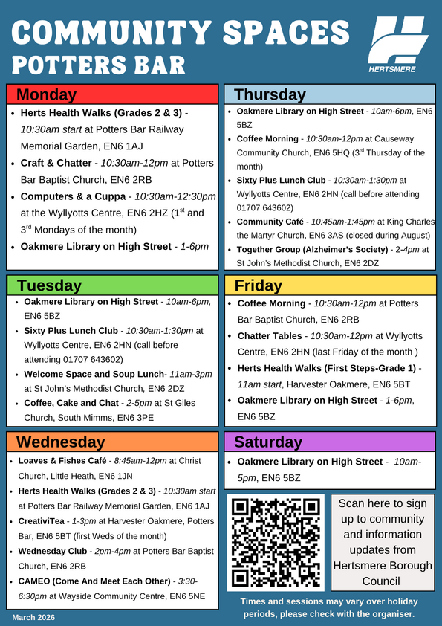

We Move, She Moves sessions in Potters Bar
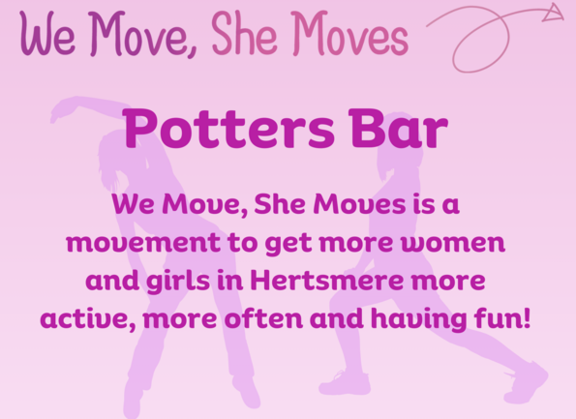
We Move, She Moves is a great way to get active and have fun! Take a look at the weekly sessions near you.
Activity | Date & Time | Location | Price
Tai Chi | Mondays 2-3pm | Wyllyotts Theatre | £5 (women only)
Yoga | Tuesdays 6-7pm | Oakmere Primary School | £5 (women only)
Pilates | Tuesdays 6:30-7:30pm | Wyllyotts Theatre | £5 (women only)
Active Trampolining | Mondays 8-9pm | Furzefield Leisure Centre | £3 (all genders 18+)
Please visit our website for our weekly timetable and Facebook page @WeMoveSheMoves for other session updates to find out what's on near you and how to book. For more information, email community.services@hertsmere.gov.uk or call 020 8207 7801.

Healthy Hub Hertsmere
Our Healthy Hubs provide FREE lifestyle support for individuals and their families covering mental health, physical activity, weight management, smoking cessation, health MOTs and nutritional advice, and sexual health testing kits.
Contact Lee or Nicola to make a face-to-face appointment or phone:
Lee Bruce: Lee.Bruce@inspireall.com or 07741 248852
Nicola O'Neill: healthyhub@communities1st.org.uk or 01727 649931
Find out more at the Healthy Hub website.
Alternatively, visit our Healthy Hub Self Service page, where you can access all of the services you need online. If you would like to access free health advice, fill out the enquiry form and we'll get back to you.
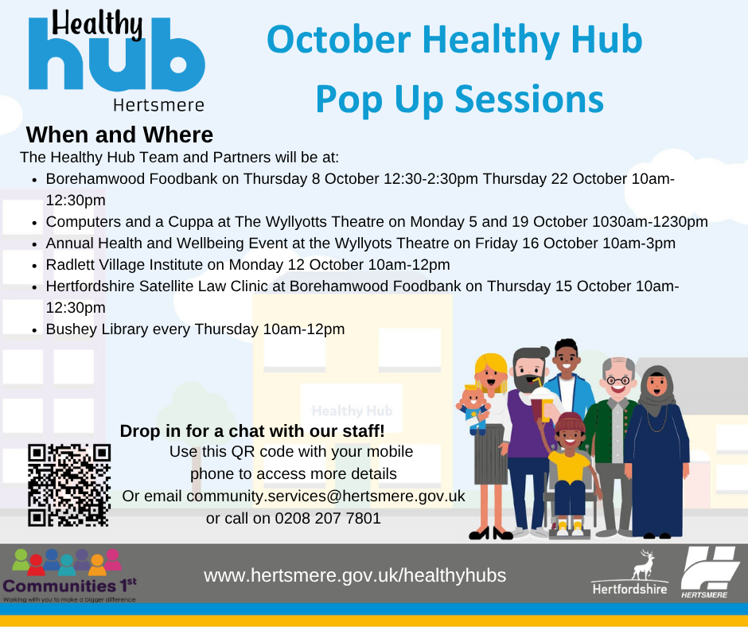
For further details on how to keep healthy in Hertsmere and to use our new interactive map, please use this link Health in Hertsmere.
You can also visit the Potters Bar Healthy Hub every Friday between 9.30am and 4.30pm at Wyllyotts Theatre. Services include exercise on referral, weight-loss advice, health MOTs, nutritional advice, public health services, fitness classes, mental health outreach, community support service and group activities.
Online and phone-ins also available. Call 07741 248852 or email Lee Bruce.
Home Fire Safety Checks
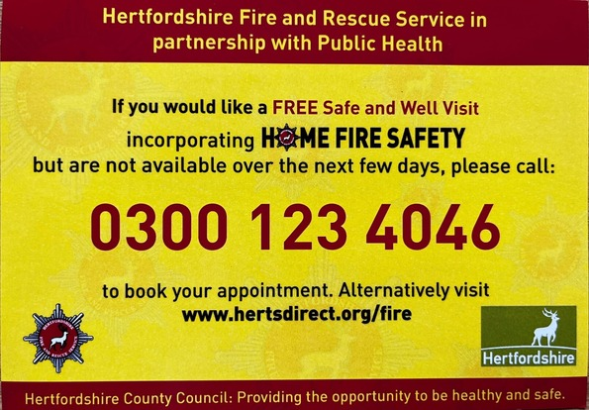

Worrying about Money - Find out what's available to you. Find all Financial Support - Hertsmere Borough Council.
Cost of Living Toolkit - If you need help or advice about the support you could receive with the cost of living, please visit Help to manage the cost of living | Hertfordshire County Council
Food Aid Providers - Use the Hertfordshire directory to find food support near you: Hertfordshire Directory - Food Support.
Pension Credit Support - If you're over State Pension age, you may be able to claim Pension Credit to top up your income. To find out if you are eligible for Pension Credit, contact Age UK Hertfordshire on 0300 345 3446 or email info@ageukherts.org.uk.
Mental Health Support - Advice and support for your happiness, wellbeing and mental health.
See what other services are available to you by visiting Cost of Living or calling 0300 123 4044.
www.hertsmere.gov.uk
customer.services@hertsmere.gov.uk
020 8207 2277
Civic Offices, Elstree Way, Borehamwood, WD6 1WA

