
Potters Bar Community Connections
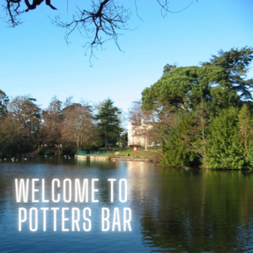 |  | Keeping Potters Bar connected  Welcome to the latest edition of the Potters Bar Community Connections newsletter, in which you can find information about news and events in the local community.

Potters Bar Health and Wellbeing Event
The Potters Bar Health & Wellbeing event is back this September, with over 25 stalls offering wellbeing information and advice. You can expect a range of different stalls from local and national health services, talks from Age UK, Memory Support Herts, Bowel Cancer UK, Parkfield, Highview and Annandale GPs as well as six taster sessions ranging from dance, singing and chair based activities! No booking required!
For more information please email friendsofparkfieldppg@gmail.com
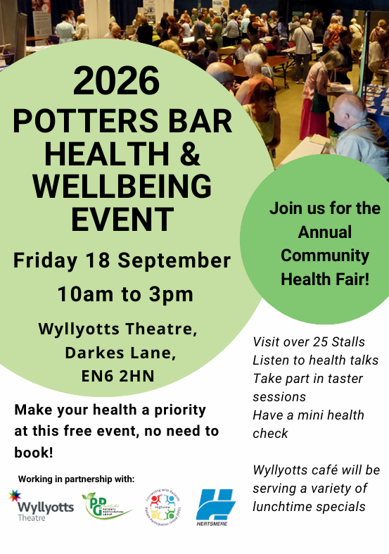

The Friends
The Friends is a registered charity that has been supporting the community of Hertfordshire for over 20 years. They provide live entertainment every weekend for the isolated, lonely, the disabled and families living with Dementia.
For more information please contact them directly on 01923 289890 or email info@friendsofcarehomes.com. Please see they flyer below for further information or visit their website.
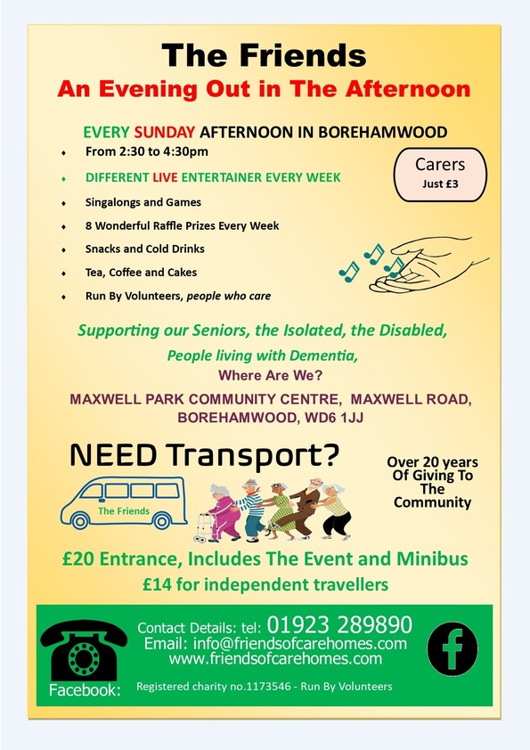

The Big Conversation on Care
The Big Conversation on Care has now launched, and you are invited to share your views on adult social care. Whether you use care services, care for someone else, work in the sector, or have opinions on how care should work in the future, you can have your say and help shape the future of care.
Find out more here: The Big Conversation on Care | The Casey Commission
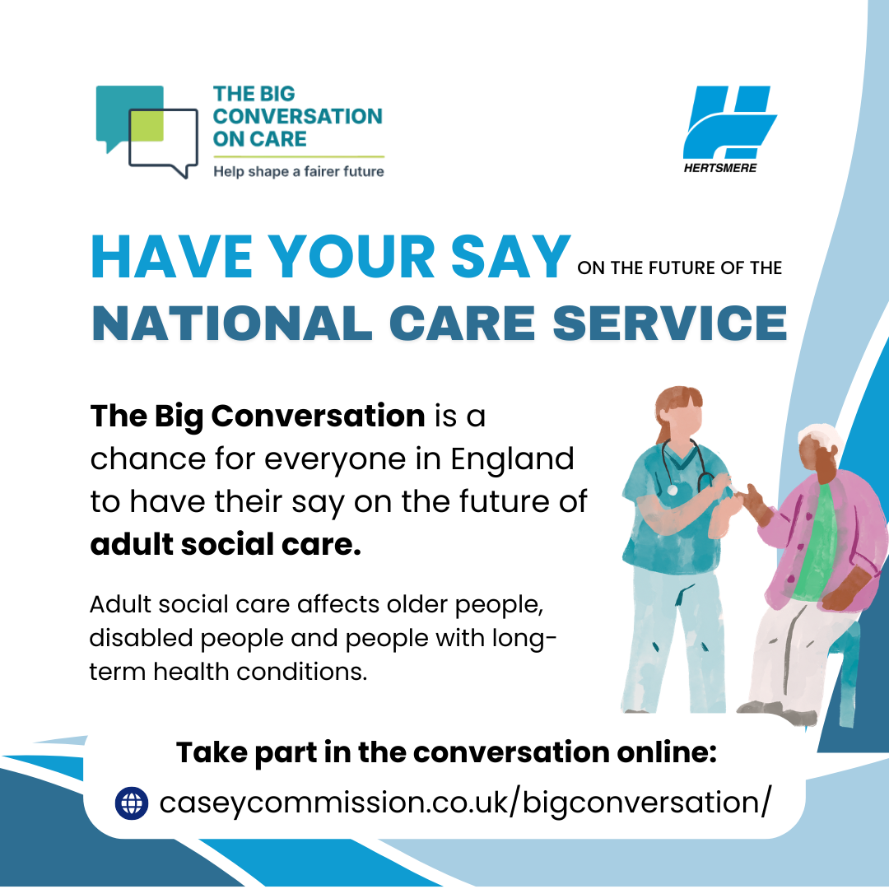

Potters Bar Choral Society
Love to sing? Join the Potters Bar Choral Society today! They are a friendly choir of around 30 members who share a simple philosophy: sing, have fun, and enjoy making music together! Their repertoire ranges from classical favourites by Verdi, Mozart, Handel and Bach to Gershwin, Gilbert & Sullivan, folk songs, swing and lighter music.
New members are always welcome, with no audition required. They ask only for enthusiasm and a commitment to attend regularly. Sight-reading is not necessary, and you're welcome to try three rehearsals before deciding to join.
Founded in 1961, they've been bringing music to Potters Bar and the surrounding area for over 60 years.
Rehearsals: Tuesdays, 8-10pm at St Mary's Church Hall, The Walk, Potters Bar EN6 1QQ
If you'd like to find out more please email info@pbchoral.org or visit Potters Bar Choral Society
Upcoming event: Come and Sing Gilbert and Sullivan, extracts from The Pirates of Penzance! On Saturday 3 October 2026 from 2:30-5:30pm at St Mary's Church, The Walk, EN6 1QQ. Everyone welcome, no booking required!


Gender Based Abuse Service
Mimram is a service that specialises in providing practical and emotional support, as part of a co-ordinated multi-agency response to meeting the needs of survivors of all forms of Violence Against Women and Girls. That includes domestic, sexual, technology-facilitated and economic abuse and so-called ‘honour’ based violence, as well as coercive control, modern slavery and human trafficking, working in the sex industry, forced marriage, stalking and female genital mutilation.
The service is available for women, children and men of all ages who are living in Hertfordshire and are experiencing a form of gender-based abuse.
To find out more information or to get support please visit www.mimramsupport.co.uk
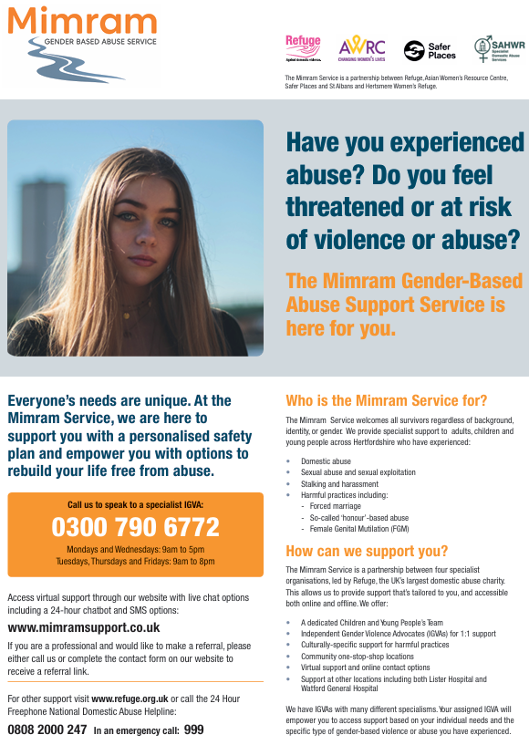
Hertsmere Community Lottery
It’s A Win-Win Situation When You Play Hertsmere Community Lottery!
Support local good causes and be in with a chance to win great prizes by joining the Hertsmere Community Lottery for just £1 a week. As well as weekly cash prizes of up to £25,000, tickets for the Saturday 31 October draw also enter you into a special Super Draw to win a brand new iPhone set to be released in September! You can choose which cause your ticket supports, with more of your money going directly to your chosen organisation than most major lotteries, and excellent odds of winning at 50:1. Whether you play weekly or just for the Super Draw, it’s a simple, fun way to give back, with thousands already raised for local charities—making it a true win-win.
Play Here - Hertsmere Community Lottery
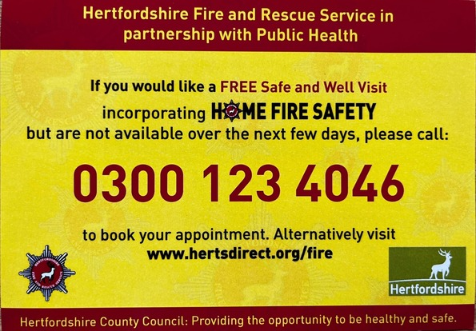
Home Fire Safety Checks

Potters Bar Community Spaces
Meet like-minded people, enjoy hot drinks, food, games, walks or just a chat at one of the many community spaces across Potters Bar and South Mimms. Most groups offer a warm space, beverage and snack or meal for free, or for a small donation. No need to book - just pop along to one of the groups and you'll be met with open arms.
For more community spaces across the borough, please visit Hertsmere Community Spaces
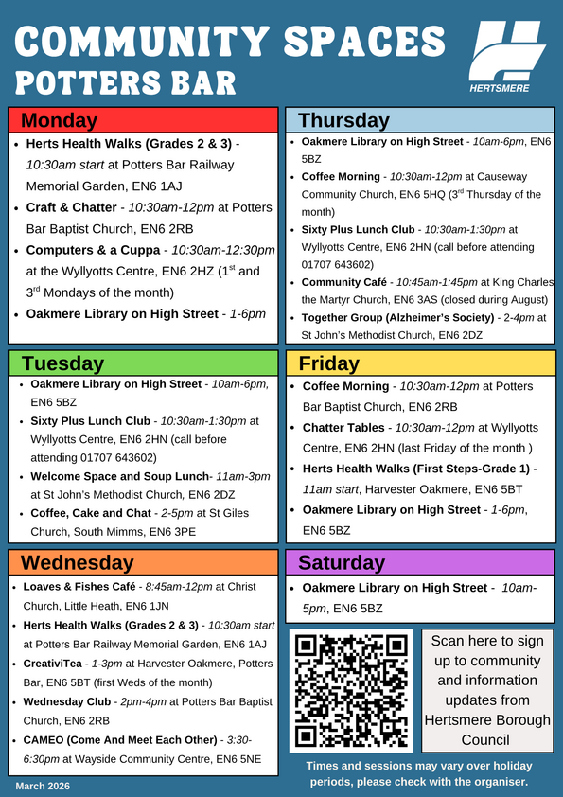
If you're interested in the Herts Health Walks, please visit Hertfordshire Health Walks | Hertfordshire County Council for further information on the different grades and how to register for walks - please arrive at least 10 minutes before the start time of each walk.
We Move, She Moves sessions in Potters Bar
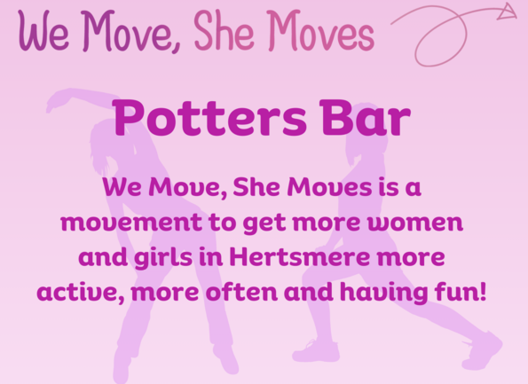
We Move, She Moves is a great way to get active and have fun! Take a look at the weekly sessions near you.
Activity | Date & Time | Location | Price
Tai Chi | Mondays 2-3pm | Wyllyotts Theatre | £5 (women only)
Yoga | Tuesdays 6-7pm | Oakmere Primary School | £5 (women only)
Pilates | Tuesdays 6:30-7:30pm | Wyllyotts Theatre | £5 (women only)
Active Trampolining | Fridays 8-9pm | Furzefield Leisure Centre | £3 (all genders 18+)
Please visit our website for our weekly timetable and Facebook page @WeMoveSheMoves for other session updates to find out what's on near you and how to book. For more information, email community.services@hertsmere.gov.uk or call 020 8207 7801.
Healthy Hub Hertsmere
Our Healthy Hubs provide FREE lifestyle support for individuals and their families covering mental health, physical activity, weight management, smoking cessation, health MOTs and nutritional advice, and sexual health testing kits.
Contact Lee or Nicola to make a face-to-face appointment or phone:
Lee Bruce: Lee.Bruce@inspireall.com or 07741 248852
Nicola O'Neill: healthyhub@communities1st.org.uk or 01727 649931
Find out more at the Healthy Hub website.
Alternatively, visit our Healthy Hub Self Service page, where you can access all of the services you need online. If you would like to access free health advice, fill out the enquiry form and we'll get back to you.
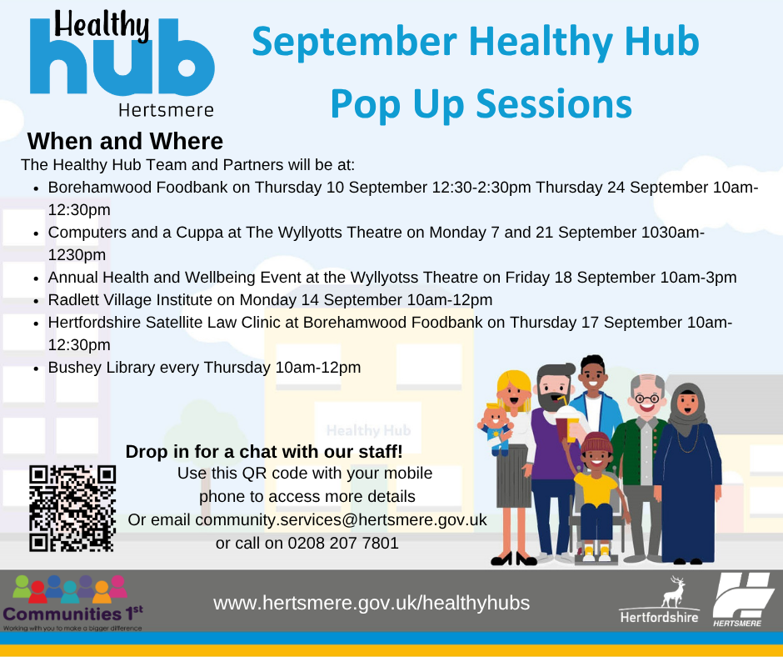
For further details on how to keep healthy in Hertsmere and to use our new interactive map, please use this link Health in Hertsmere.
You can also visit the Potters Bar Healthy Hub every Friday between 9.30am and 4.30pm at Wyllyotts Theatre. Services include exercise on referral, weight-loss advice, health MOTs, nutritional advice, public health services, fitness classes, mental health outreach, community support service and group activities.
Online and phone-ins also available. Call 07741 248852 or email Lee Bruce.

Worrying about Money - Find out what's available to you. Find all Financial Support - Hertsmere Borough Council.
Cost of Living Toolkit - If you need help or advice about the support you could receive with the cost of living, please visit Help to manage the cost of living | Hertfordshire County Council
Food Aid Providers - Use the Hertfordshire directory to find food support near you: Hertfordshire Directory - Food Support.
Pension Credit Support - If you're over State Pension age, you may be able to claim Pension Credit to top up your income. To find out if you are eligible for Pension Credit, contact Age UK Hertfordshire on 0300 345 3446 or email info@ageukherts.org.uk.
Mental Health Support - Advice and support for your happiness, wellbeing and mental health.
See what other services are available to you by visiting Cost of Living or calling 0300 123 4044.
www.hertsmere.gov.uk
customer.services@hertsmere.gov.uk
020 8207 2277
Civic Offices, Elstree Way, Borehamwood, WD6 1WA


SUBSCRIBER SERVICES:
Manage Preferences | Unsubscribe | Help | Contact us



