

Free Film & TV Programme Opens Industry Doors for Hertsmere Teenagers

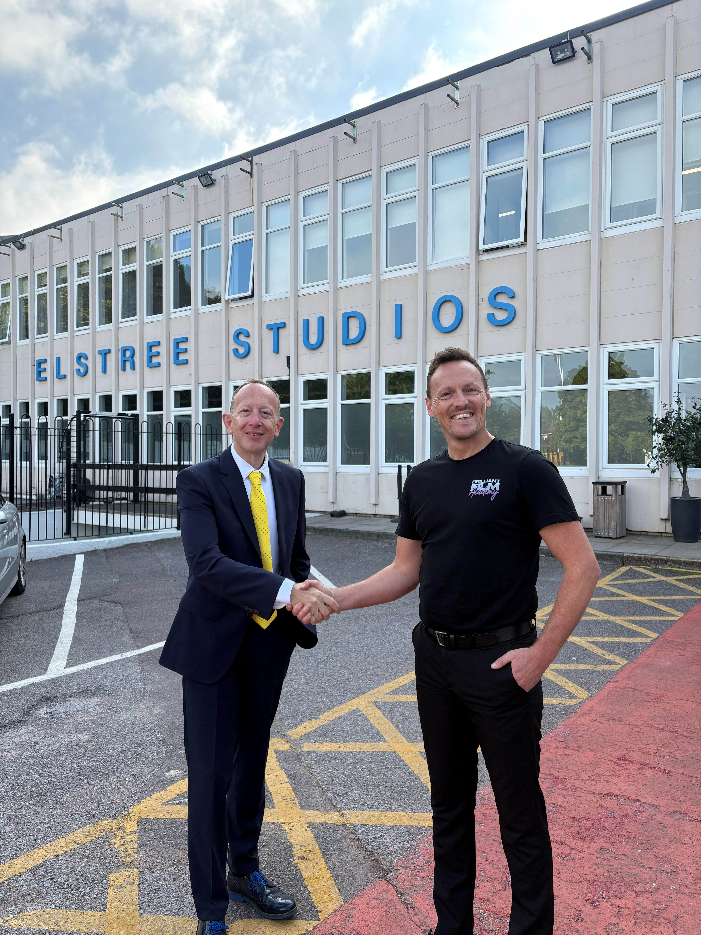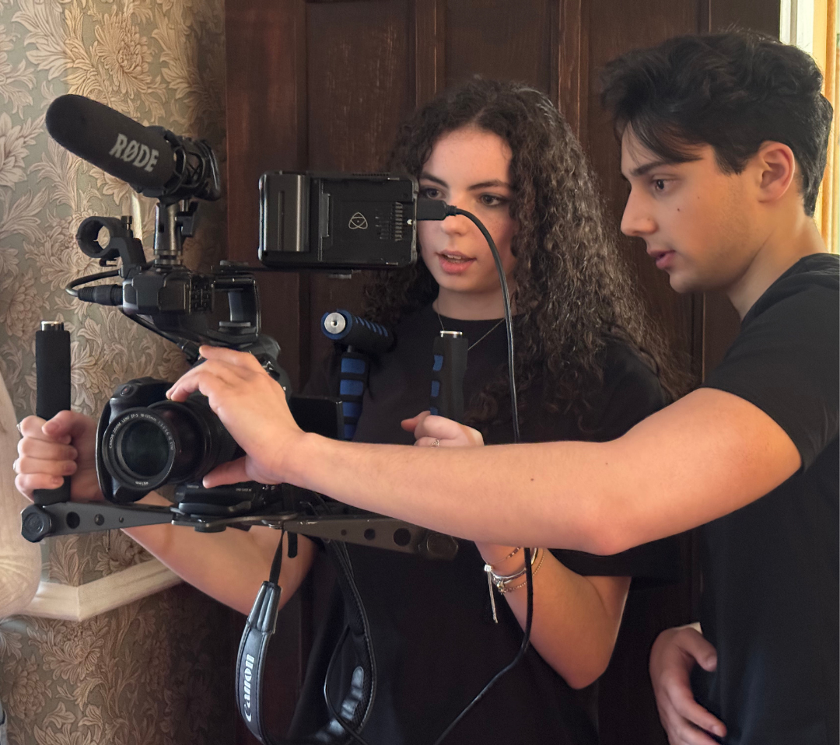

Photo caption: Up to 30 young people will have the chance to create, shoot and premiere an original short film, explore careers and gain hands-on experience as Hertsmere Creative Futures launches with a free October half-term programme.

(September 2026, Hertsmere, Herts.) Hertsmere Borough Council through its dedicated venture Hertsmere Creatives Futures are offering young people aged 11-17 living in Hertsmere the chance to step behind the camera and discover where a career in Film and TV could take them, through a brand new free five-day filmmaking programme running this October half term.

Hertsmere Creative Futures launches with its first project, a filmmaking programme running from 26–30 October 2026, giving up to 30 local young people the opportunity to gain real industry experience as they make and premiere an original short film or creative project and explore the many different jobs available in production, which could include everything from operating the camera to set design, from scriptwriting to editing.

The course will be delivered by the experts at Brilliant Film Academy, with funding from Hertsmere Borough Council, and aims to demonstrate the positive impact of the local Film and TV industry by connecting young people from Hertsmere with the screen opportunities available on their doorstep.

Over the five days, participants will gain experience across the complete filmmaking process, from developing ideas and pre-production through to filming, post-production and screening. They will also learn about the creative, technical, production and business roles within the Film and TV industry.

The programme will also include a practical session led by BRAVE FX to learn all about special effects.

Applications are open to young people aged 11–17 living in Hertsmere, and no previous filmmaking experience or technical knowledge is necessary – just a willingness to learn and an interest in film.

David Jenkins, founder of Brilliant Film Academy, said:

“Hertsmere has an incredible Film and TV industry on its doorstep, and this programme is about helping local young people see that there could be a place for them within it.

“We want participants to learn filmmaking by actually doing it, while also discovering the huge range of careers that exist behind the scenes. You don’t need previous experience, just curiosity and a passion for film.

“For some young people, this could be their first real introduction to the screen industries, and we hope it gives them the skills, insight and inspiration to start thinking seriously about where that interest could take them.”

Successful applicants will be asked to pay a £50 refundable deposit to secure their place. The deposit will be refunded on completion of the programme and may be waived where it presents a barrier to participation.
Cllr Jeremy Newmark, Leader of Hertsmere Borough Council said:
“Hertsmere has a remarkable film and television heritage and a hugely successful industry, and is the home of Elstree Film Studios, Sky Studios Elstree, and Fairbank Studios, but we want its legacy to be about the future as well as the past.
"Behind every production are hundreds of people doing different jobs. Whatever a young person’s interests – design, finance, catering or a more traditional creative role – there could be a career for them in the screen industry.
“Hertsmere Creative Futures is about making these opportunities visible to our young people. We want the industry on their doorstep, to be an industry that is open to them. I see this as the start of a pipeline from Hertsmere’s classrooms to Hertsmere’s studios.
"We want Hertsmere Creative Futures to grow, investing in local talent and taking the industry that is on our doorstep and turning it into opportunities and jobs for our residents.”
Find out more information and apply for a place, visit: www.brilliantfilmacademy.co.uk/october2026

Applications will close at 5pm on 19 October 2026.

***ENDS***

Press office (PR4):
- Faye Ferriday: faye@pr4.com
- Alison Peart@pr4.com
- Chrissie Wright: chrissie@pr4.com / +44 7957 383070

Notes to Editors

The first photograph at Elstree Studios is available for use. Left to right, Cllr Jeremy Newmark, Leader of Hertsmere Borough Council shaking hands with David Jenkins, Founder of Brilliant Film Academy.

The second photograph of two Brilliant Film Academy students with camera equipment is also available for media use. © Brilliant Film Academy

About Hertsmere Creative Futures:
- Hertsmere Creative Futures is the overarching Hertsmere Borough Council initiative that will build on the borough’s rich screen heritage, creating stronger links between local young people and the thriving local film and television industry.
- The Film & TV Careers and Practical Filmmaking Programme is developed and delivered by Brilliant Film Academy.
- This first initiative of the Hertsmere Creative Futures programme will accommodate up to 30 young people aged 11–17 living within Hertsmere and will take place in Borehamwood.

About Brilliant Film Academy:
- Brilliant Film Academy provides hands-on, industry-led filmmaking training for young people aged 11–19 in St Albans and Dacorum. Students learn the full filmmaking process, from pre-production to post-production, using professional equipment and real-world techniques.
- Founded by David Jenkins in 2015, The Brilliant Academies are Hertfordshire’s leading destination for serious training across Theatre, Dance and Film, delivering creativity and future-ready skills for young people interested in careers in the creative industries.

