
Potters Bar Community Connections
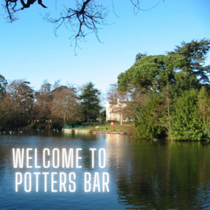 |  | Keeping Potters Bar connected  Welcome to the latest edition of the Potters Bar Community Connections newsletter, in which you can find information about news and events in the community.

Have your say on proposals for a Potters Bar parish council
Following an initial consultation earlier this year, Hertsmere Borough Council has published a set of draft proposals setting out how a parish council could operate in Potters Bar, including the proposed number of parish councillors and how the area could be divided into wards.
The second stage of consultation opens Wednesday 1 July and closes at midnight on Sunday 23 August 2026.
The first stage of the review ran from 21 April to 8 June 2026 and received 604 responses. Of those who took part, 72 per cent supported the establishment of a parish council. All responses have been anonymised and published on the council’s website. The feedback received has helped shape the draft proposals now being consulted on before a final decision is made by the council in September.
Residents and businesses can view the proposals and complete the online questionnaire by visiting www.hertsmere.gov.uk/CGR or by scanning the QR code displayed on consultation materials.
Anyone who would prefer to respond by phone or request a paper questionnaire can contact the council’s Electoral Services Team on 020 8207 7481 or email elections@hertsmere.gov.uk.
We will also be holding two public sessions where you can find out more and raise any questions you may have:
- Monday 13 July: 12:30 – 14:30
- Wednesday 19 August: 18:30 – 20:30
These will be at the Wyllyots Theatre, Wyllyots Place, Darkes Lane, Potters Bar, Herts EN6 2HZ.
The deadline for responses is midnight on Sunday 23 August 2026.

New SightLife group in Potters Bar

Herts Vision Loss have created a new SightLife group in Potters Bar for individuals who are blind and partially sighted. The launch event will take place on Thursday 23 July 2026 at The Wyllyotts Theatre from 11am-2pm. This will be a great opportunity for local people living with sight loss to come together, meet others, and help shape the future of the group. They’ll be gathering ideas, feedback, and suggestions to ensure the group reflects the needs and interests of its members. There will also also be a couple of guest speakers attending, and lunch and refreshments will be provided.
Following the launch, the group will meet on the first Thursday of each month from 11am-1pm in the Wyllyotts Café, with the first official meeting on Thursday 6 August 2026. They would love for people to come along for a friendly chat, a cuppa, a slice of cake, and the chance to meet fellow members, as well as their wonderful volunteer Group Lead, Anita!
If you have any questions or want to find out more email office@hertsvisionloss.org.uk or call 01707 324 680.
Citizens Advice Drop-in Sessions
Need help or advice? Citizens Advice offers free, confidential and independent support on a wide range of issues, including benefits, debt, housing, employment, consumer rights and more. Whether you need help understanding your options, completing forms or resolving a problem, pop in to their upcoming drop-in service and speak to someone who can help.
The drop-in sessions are free to attend and no booking is required, just show up on the day and speak to someone! Sessions are on every Thursday in July from 2-4pm at Elm Court Community Centre.
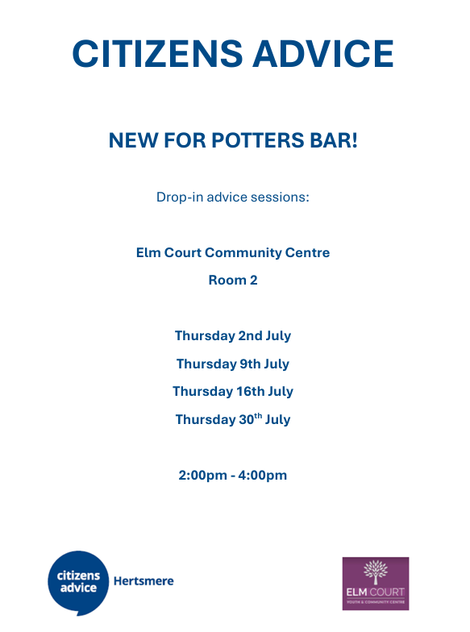
Visit Citizens Advice Hertsmere for more information on how to access support.

Carers Support Group
Parkfield Patient Participation Group (PPG) alongside other PPG groups and Carers in Herts host a monthly coffee morning for all carers in Potters Bar. It is an informal setting where you can come and meet their friendly volunteers and chat with other carers and representatives from the surgery and Carers in Herts, who can provide practical support and advice where needed. No need to book, just show up and you'll be greeted with open arms.
They look forward to welcoming carers at their next coffee mornings on 8 July, 12 August, 9 September, and every second Wednesday of the month, at St Mary the Virgin & All Saints Church Hall, The Walk, EN6 1QQ. For more information please email friendsofparkfieldppg@gmail.com.
Keep up to date with Parkfield PPG on Facebook - Here
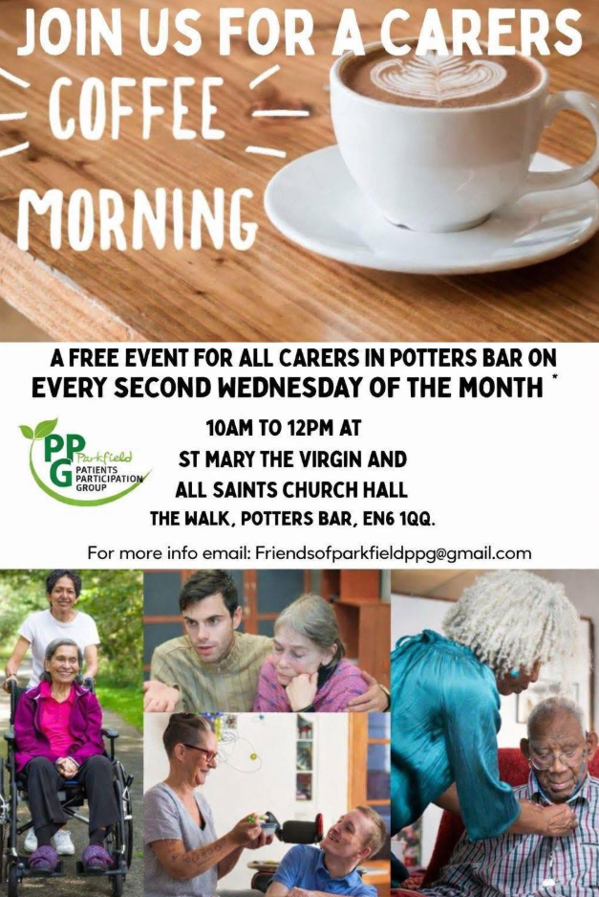

Sixty Plus Centre
If you're aged 60 or over, why not join the friendly Sixty Plus Lunch Club at the Wyllyotts Centre? Open every Tuesday and Thursday, members can enjoy a freshly cooked two-course lunch with tea or coffee for £8.50, with optional bingo from 11am and lunch served at 12 noon. Guests are welcome to arrive from 9.30am onwards, making it a great opportunity to meet new people, socialise and reduce isolation in a warm (or cool!) and welcoming environment. A minibus transport service is available for eligible residents of Potters Bar and South Mimms for an additional fee. The club also organises guest speakers, entertainment, afternoon tea outings, seaside trips and a festive Christmas party throughout the year.
Sixty Plus are also seeking volunteers to help run the lunch club services, if you're interested in becoming a volunteer or attending the lunch club, call 01707 643602 or email sixtypluscentre@gmail.com or visit Sixty Plus Lunch Club for more information.
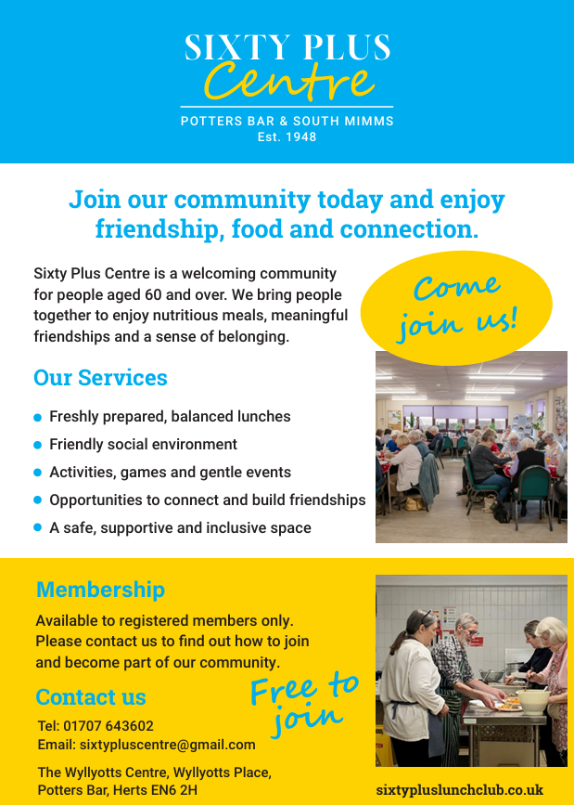
Hertsmere Community Lottery
It’s A Win-Win Situation When You Play Hertsmere Community Lottery!
Support local good causes and be in with a chance to win great prizes by joining the Hertsmere Community Lottery for just £1 a week. As well as weekly cash prizes of up to £25,000, tickets for the Saturday 29 August draw also enter you into a special Super Draw to win a £2,000 luxury getaway, perfect for a family holiday, European city break, or once-in-a-lifetime trip! You can choose which cause your ticket supports, with more of your money going directly to your chosen organisation than most major lotteries, and excellent odds of winning at 50:1. Whether you play weekly or just for the Super Draw, it’s a simple, fun way to give back, with thousands already raised for local charities—making it a true win-win.
Play Here - Hertsmere Community Lottery

We Move, She Moves sessions in Potters Bar

We Move, She Moves is a great way to get active and have fun! Take a look at the weekly sessions near you.
Activity | Date & Time | Location | Price
Tai Chi | Mondays 2-3pm | Wyllyotts Theatre | £5 (women only)
Yoga | Tuesdays 6-7pm | Oakmere Primary School | £5 (women only)
Pilates | Tuesdays 6:30-7:30pm | Wyllyotts Theatre | £5 (women only)
Active Trampolining | Fridays 2-3pm | Furzefield Leisure Centre | £3 (all genders 18+)
Please visit our website for our weekly timetable and Facebook page @WeMoveSheMoves for other session updates to find out what's on near you and how to book. For more information, email community.services@hertsmere.gov.uk or call 020 8207 7801.
CPR awareness
Learn a vital life-saving skill at our free CPR Awareness Training, delivered with the support of Potters Bar Life Saving Club. These practical evening sessions run on Wednesdays 6 May, 10 June and 15 July (7.45–9.15pm) at Elm Court Youth & Community Centre, Potters Bar, and are ideal for anyone wanting the confidence to act in an emergency.
Booking is essential call 020 8207 2277 or email community.services@hertsmere.gov.uk to secure your place.
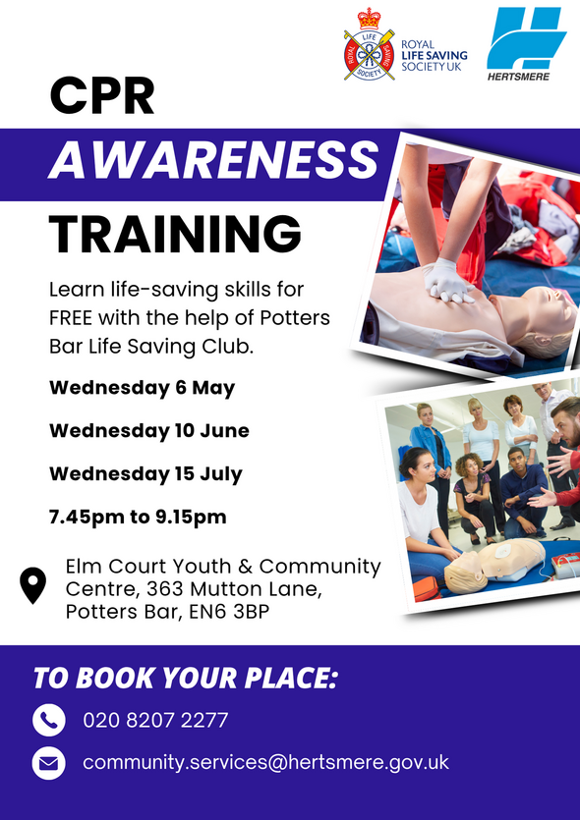

Healthy Hub Hertsmere
Our Healthy Hubs provide FREE lifestyle support for individuals and their families covering mental health, physical activity, weight management, smoking cessation, health MOTs and nutritional advice, and sexual health testing kits.
Contact Lee or Nicola to make a face-to-face appointment or phone:
Lee Bruce: Lee.Bruce@inspireall.com or 07741 248852
Nicola O'Neill: healthyhub@communities1st.org.uk or 01727 649931
Find out more at the Healthy Hub website.
Alternatively, visit our Healthy Hub Self Service page, where you can access all of the services you need online. If you would like to access free health advice, fill out the enquiry form and we'll get back to you.
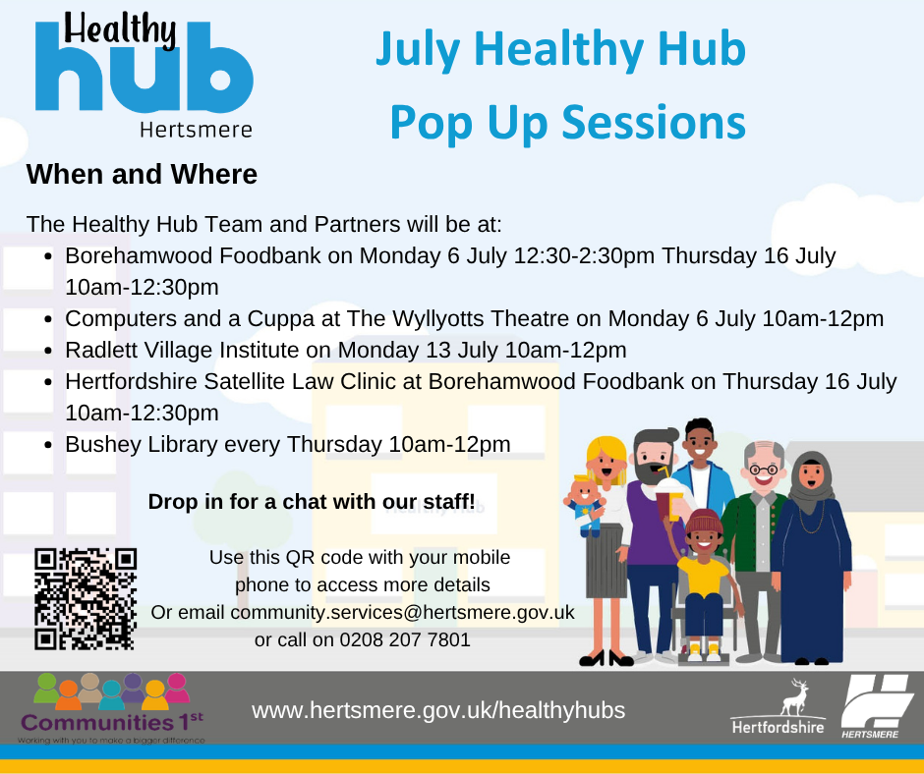
For further details on how to keep healthy in Hertsmere and to use our new interactive map, please use this link Health in Hertsmere.
You can also visit the Potters Bar Healthy Hub every Friday between 9.30am and 4.30pm at Wyllyotts Theatre. Services include exercise on referral, weight-loss advice, health MOTs, nutritional advice, public health services, fitness classes, mental health outreach, community support service and group activities.
Online and phone-ins also available. Call 07741 248852 or email Lee Bruce.
Volunteer for The Cinnamon Trust
The Cinnamon Trust is the national charity for the elderly and terminally ill and their pets. The focus of their work is to keep owners and pets together for as long as possible, with the help of a national network of volunteers who offer free assistance when day to day care poses a problem.
They are unique amongst charities as they aim to relieve owners of any worries about their pets’ welfare, both during and also after their own lifetime.
All volunteers help in the ways that are most appropriate to them. Teams take it in turn to visit housebound owners to take the dog for a walk, foster a pet if e.g. an owner faces a spell in hospital or respite care. They might take pets to the vet or just clean out the budgie's cage or cat litter trays.
They are short on volunteers in Potters Bar.
As a volunteer, the amount of time you offer is completely up to you – it could just be one dog walk a week, or a one-off trip to the vet – they would be grateful for any time you can give.
If you are interested in becoming a volunteer:
More info:www.cinnamon.org.uk
Email: appeals@cinnamon.org.uk If you would like to have a more in-depth chat about becoming a volunteer, please call them during office hours (Monday-Friday 9am-5pm) on 01736 758 701
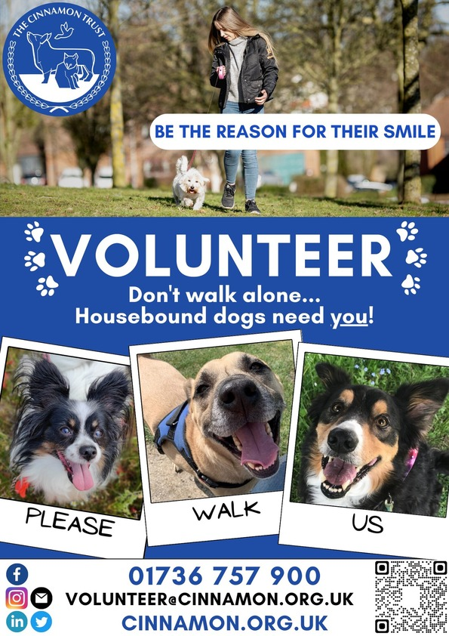

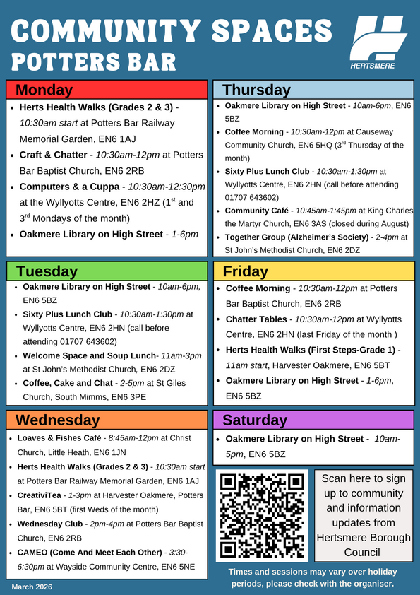
Community Spaces
For more community spaces across the borough, please visit Hertsmere Community Spaces

If you're interested in the Herts Health Walks, please visit Hertfordshire Health Walks | Hertfordshire County Council for further information on the different grades and how to register for walks - please arrive at least 10 minutes before the start time of each walk. There is currently a waiting list for Sixty Plus Lunch Club - please contact sixtypluscentre@gmail.com or call 01707 643602 before attending, to avoid disappointment.
Cost of Living and Health Support
Worrying about Money - Find out what's available to you. Find all Financial Support - Hertsmere Borough Council.
Cost of Living Toolkit - If you need help or advice about the support you could receive with the cost of living, please visit Help to manage the cost of living | Hertfordshire County Council
Food Aid Providers - Use the Hertfordshire directory to find food support near you: Hertfordshire Directory - Food Support.
Pension Credit Support - If you're over State Pension age, you may be able to claim Pension Credit to top up your income. To find out if you are eligible for Pension Credit, contact Age UK Hertfordshire on 0300 345 3446 or email info@ageukherts.org.uk.
Mental Health Support - Advice and support for your happiness, wellbeing and mental health.
See what other services are available to you by visiting Cost of Living or calling 0300 123 4044.

Home Fire Safety Checks
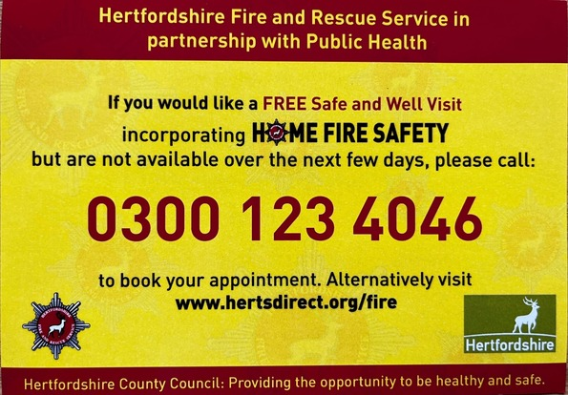

If you're worrying about money, please see All Financial Support - Hertsmere Borough Council
www.hertsmere.gov.uk
customer.services@hertsmere.gov.uk
020 8207 2277
Civic Offices, Elstree Way, Borehamwood, WD6 1WA

