
Potters Bar Community Connections
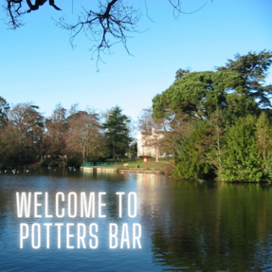 |  | Keeping Potters Bar connected  Welcome to the latest edition of the Potters Bar Community Connections newsletter, in which you can find information about news and events in the community.

Have your say on HMOs in Potters Bar
Hertsmere Borough Council is inviting residents, businesses and stakeholders to take part in a public consultation on a proposed Article 4 Direction relating to Houses in Multiple Occupation (HMOs) in parts of Potters Bar.
The consultation concerns proposals to remove permitted development rights that currently allow the change of use from a dwellinghouse (Use Class C3) to a small HMO (Use Class C4) without planning permission.
If confirmed, planning permission would be required for future changes from a family home to a small HMO within the following wards:
- Parkfield
- Oakmere
- Furzefield
- Bentley Heath & The Royds
The council says the proposed Direction is intended to help manage the concentration and distribution of HMOs in these areas and support consideration of impacts on local communities, housing mix and neighbourhood character through the planning process.
The consultation is now underway and will run until 17 June 2026.
Residents can view the consultation documents and complete an online survey via the council’s website:https://www.hertsmere.gov.uk/planning-building-control/building-tree-conservation/article-4-directions/hmo-consultation-page
All responses received during the consultation period will be considered before any decision is made on whether to confirm the Article 4 Direction. If confirmed, the Direction would come into force in May 2027.

Potters Bar Community Governance Review 2026
Hertsmere Borough Council has been asked by the electors of Potters Bar to undertake a Community Governance Review for the unparished area of Potters Bar, by way of petition, to consult on the creation of a Civil Parish and a Parish Council.
A Community Governance Review (CGR) is a process that provides an opportunity to review and make changes to governance arrangements for town and parish councils and parish areas. This means making sure that those living in the area, and other interested groups, have a say in how their local communities are represented.
In Hertsmere, parish and town council services generally include:
- Local events,
- Activities for young/older people,
- Christmas lights,
- Allotments,
- Cemeteries and parks,
- Public clocks and war memorials.
We want to hear your thoughts on the proposed creation of a Civil Parish Council in Potters Bar. Please submit your response by using our online response form below:
Potters Bar Community Governance Review Initial Consultation Form
More information about the Potters Bar Community Governance Review can be found here:
Potters Bar Community Governance Review 2026 - Hertsmere Borough Council.
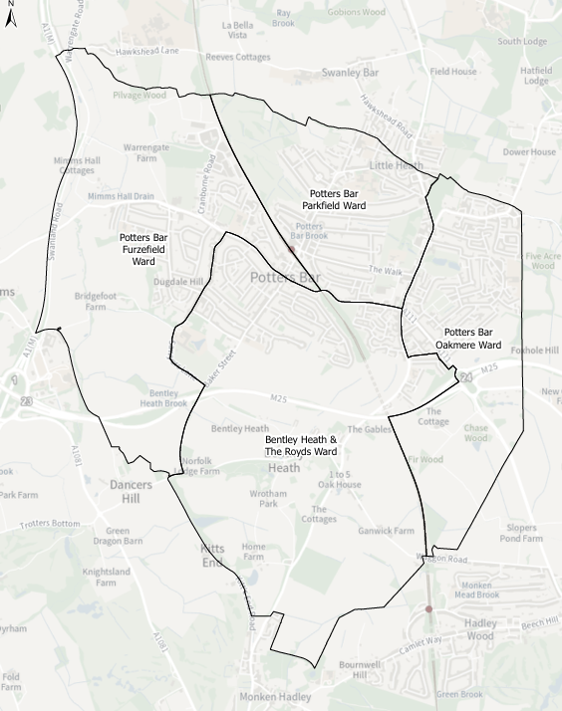

OPALS Event Potters Bar
An OPALS (Older Persons Activity, Learning and Safety) event is taking place on Friday 26 June, 10am to 2pm at Wyllyotts Theatre, Potters Bar.
This friendly, sociable event offers older residents the chance to access advice, wellbeing support and local services, helping to reduce loneliness and promote independence. Attendees can enjoy a programme of talks, visit information stalls, and meet others in the community.
Guests will be seated throughout and provided with refreshments and a free hot meal, along with advice, information and small giveaways—including a gift bag to take home.
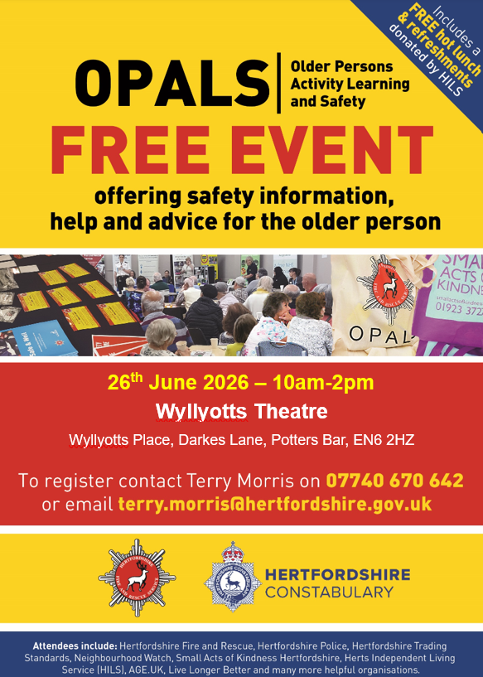
Spaces are limited, so booking is recommended via terry.morris@hertfordshire.gov.uk or 07740 670 642.

International Yoga Day
Celebrate International Yoga Day with a free outdoor session at Parkfield Park, Potters Bar on Friday 19 June, 12:30pm–1:30pm.
This relaxed session is open to all abilities—just bring a mat or towel and a drink, and enjoy moving outdoors with others.
Free to attend, please book your space!
📧 community.services@hertsmere.gov.uk
📞 0208 207 7801
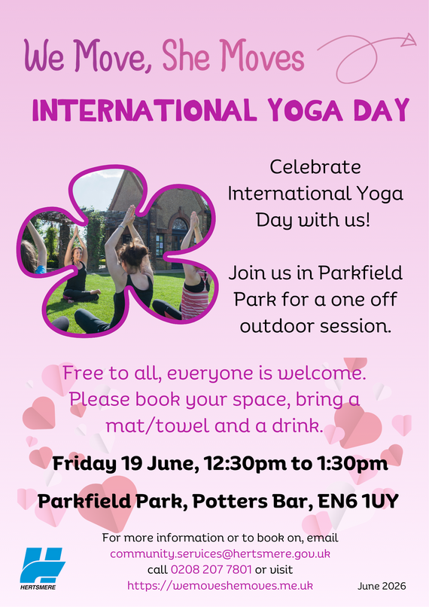
Book Here: We Move She Moves

We Move, She Moves sessions in Potters Bar
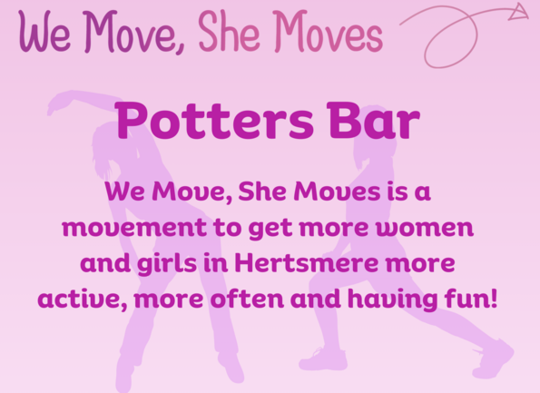
We Move, She Moves is a great way to get active and have fun! Take a look at the weekly sessions near you.
Activity | Date & Time | Location | Price
Tai Chi | Mondays 2-3pm | Wyllyotts Theatre | £5 (women only)
Yoga | Tuesdays 6-7pm | Oakmere Primary School | £5 (women only)
Pilates | Tuesdays 6:30-7:30pm | Wyllyotts Theatre | £5 (women only)
Active Trampolining | Fridays 2-3pm | Furzefield Leisure Centre | £3 (all genders 18+)
Please visit our website for our weekly timetable and Facebook page @WeMoveSheMoves for other session updates to find out what's on near you and how to book. For more information, email community.services@hertsmere.gov.uk or call 020 8207 7801.
Summer Evening Walks in Hertsmere
A new programme of Summer Evening Walks is launching across Hertsmere this June — perfect for staying active and enjoying the countryside after work.
These are longer, fast-paced walks, ideal for those looking for a more challenging route. The first walk takes place on 2 June in Aldenham.
No need to book. Just drop by on the day. To find other walks in Hertsmere visit: Hertsmere Health Walks Timetable May - August 2026
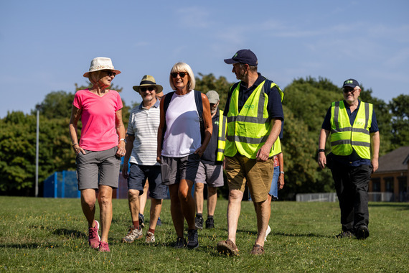

CPR awareness
Learn a vital life-saving skill at our free CPR Awareness Training, delivered with the support of Potters Bar Life Saving Club. These practical evening sessions run on Wednesdays 6 May, 10 June and 15 July (7.45–9.15pm) at Elm Court Youth & Community Centre, Potters Bar, and are ideal for anyone wanting the confidence to act in an emergency.
Booking is essential call 020 8207 2277 or email community.services@hertsmere.gov.uk to secure your place.
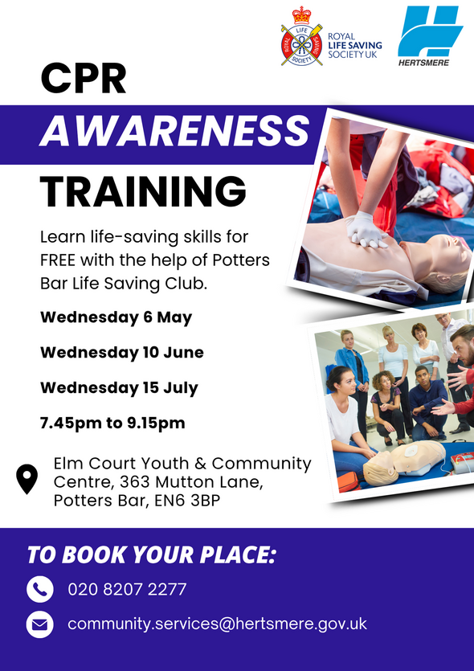

Healthy Hub Hertsmere
Our Healthy Hubs provide FREE lifestyle support for individuals and their families covering mental health, physical activity, weight management, smoking cessation, health MOTs and nutritional advice, and sexual health testing kits.
Contact Lee or Nicola to make a face-to-face appointment or phone:
Lee Bruce: Lee.Bruce@inspireall.com or 07741 248852
Nicola O'Neill: healthyhub@communities1st.org.uk or 01727 649931
Find out more at the Healthy Hub website.
Alternatively, visit our Healthy Hub Self Service page, where you can access all of the services you need online. If you would like to access free health advice, fill out the enquiry form and we'll get back to you.
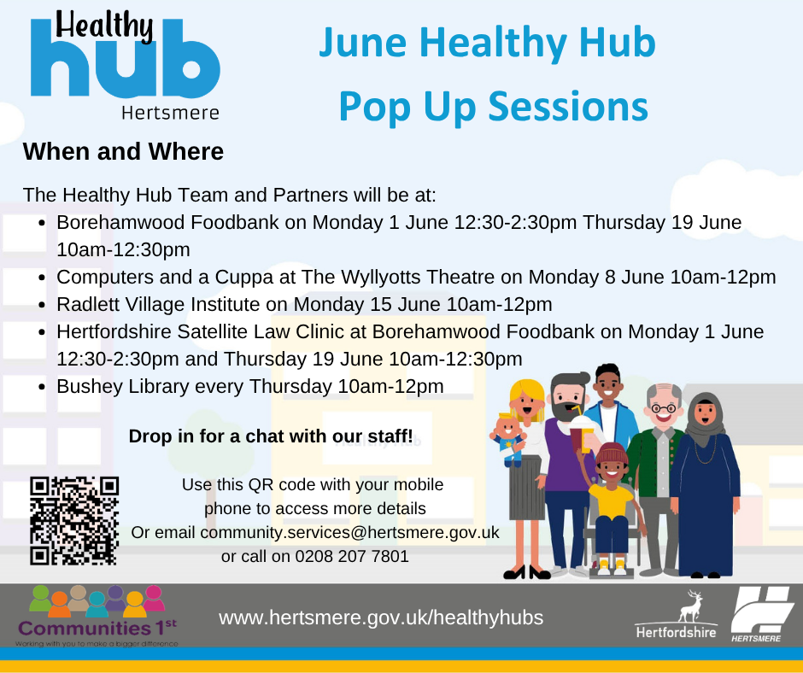
For further details on how to keep healthy in Hertsmere and to use our new interactive map, please use this link Health in Hertsmere.
You can also visit the Potters Bar Healthy Hub every Friday between 9.30am and 4.30pm at Wyllyotts Theatre. Services include exercise on referral, weight-loss advice, health MOTs, nutritional advice, public health services, fitness classes, mental health outreach, community support service and group activities.
Online and phone-ins also available. Call 07741 248852 or email Lee Bruce.
Community Spaces
Meet like-minded people, enjoy hot drinks, food, games, walks or just a chat at one of the many community spaces across Potters Bar and South Mimms. Most groups offer a warm space, beverage and snack or meal for free, or for a small donation. No need to book - just pop along to one of the groups and you'll be met with open arms.
For more community spaces across the borough, please visit Hertsmere Community Spaces

If you're interested in the Herts Health Walks, please visit Hertfordshire Health Walks | Hertfordshire County Council for further information on the different grades and how to register for walks - please arrive at least 10 minutes before the start time of each walk. There is currently a waiting list for Sixty Plus Lunch Club - please contact sixtypluscentre@gmail.com or call 01707 643602 before attending, to avoid disappointment.
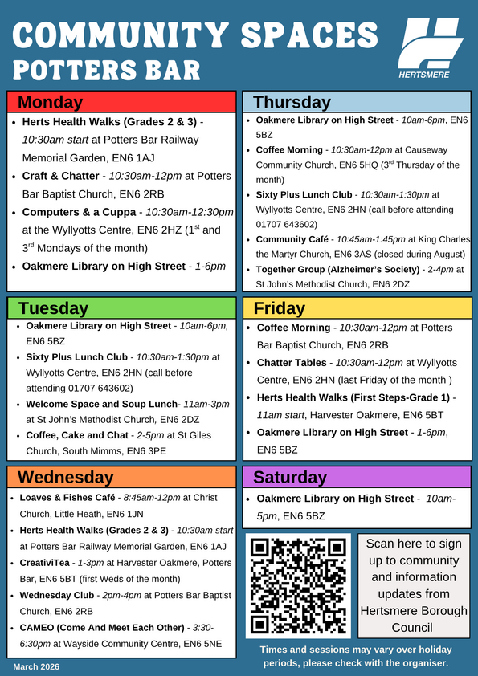

Antiques Valuation Day
Barchester Healthcare are delighted to invite you to an Antiques Valuation afternoon at Bushey House Beaumont, WD23 1QN on Tuesday 16 June, from 2-4pm.
Bushey Auctions will be in attendance, with a specialist valuer focusing on jewellery and another staff member available to assess all other items, so it’s the perfect opportunity to discover what hidden treasures you may have tucked away at home!
To help minimise congestion, they kindly ask that you park in the Country Club Car Park (WD23 1BL) next door. If you would like to attend, please let them know by calling 020 8421 8844 or emailing sarah.pratt@barchester.com
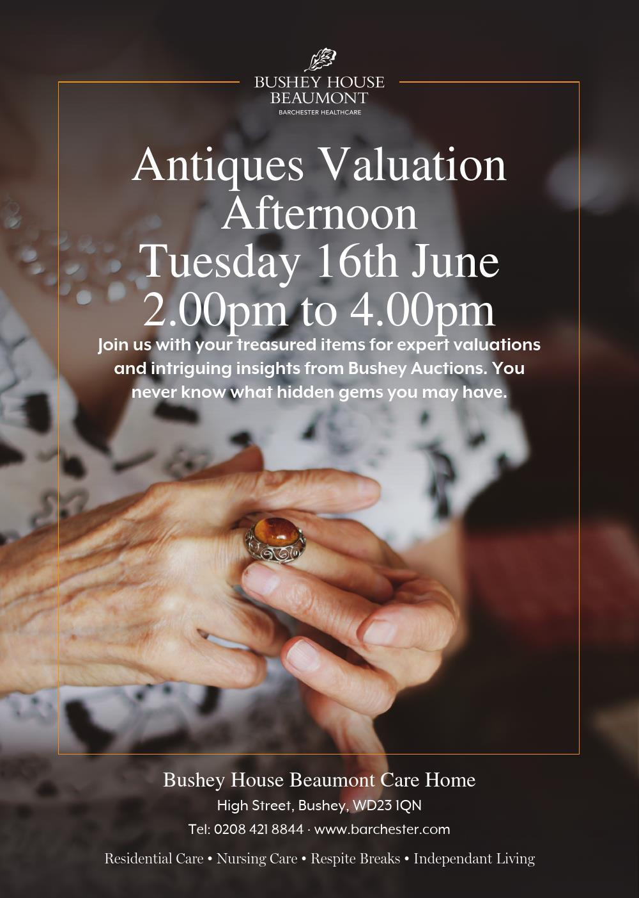

Cost of Living and Health Support
Worrying about Money - Find out what's available to you. Find all Financial Support - Hertsmere Borough Council.
Cost of Living Toolkit - If you need help or advice about the support you could receive with the cost of living, please visit Help to manage the cost of living | Hertfordshire County Council
Food Aid Providers - Use the Hertfordshire directory to find food support near you: Hertfordshire Directory - Food Support.
Pension Credit Support - If you're over State Pension age, you may be able to claim Pension Credit to top up your income. To find out if you are eligible for Pension Credit, contact Age UK Hertfordshire on 0300 345 3446 or email info@ageukherts.org.uk.
Mental Health Support - Advice and support for your happiness, wellbeing and mental health.
See what other services are available to you by visiting Cost of Living or calling 0300 123 4044.
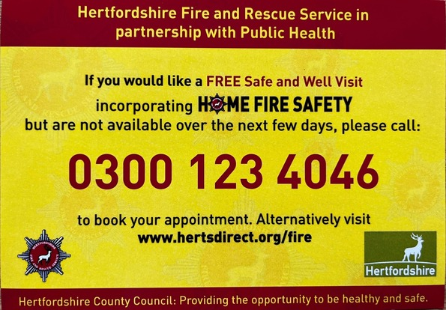
Home Fire Safety Checks

If you're worrying about money, please see All Financial Support - Hertsmere Borough Council
www.hertsmere.gov.uk
customer.services@hertsmere.gov.uk
020 8207 2277
Civic Offices, Elstree Way, Borehamwood, WD6 1WA

